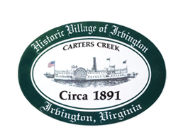

THE TOWN OF IRVINGTON

PLANNING COMMISSION REGULAR CALLED MEETING
Irvington Town Office, 4203 Irvington Rd., IRVINGTON, VA
TUESDAY, October 3, 2023; 6:30PM

Preliminary Agenda

- Call to Order – T. Chapman

- Roll Call and Determination of Quorum – T. Chapman

- Approve Minutes
- 9/5/2023 Minutes approval – T. Chapman

- Report From Chair- T. Chapman

- Public Comment

- Report from Zoning Administrator – Justin Nelson

- Old Business
a. Status of enforcement recommendations – R. Fuller
b. Zoning ordinance review status and discussion – T. Chapman
c. Draft Comprehensive Plan Review status - T. Chapman
d. STR CUP #Bristol.2023 52 York Rd -J. Nelson
e.. STR CUP #Ralls.2023 294 Chesapeake Dr- J. Nelson

- New Business

- Round Table - All

- Next meeting Election Day?
November 7, 2023, PC Regularly Scheduled Meeting at Irvington Town Hall, 6:30 p.m.

- Adjourn

