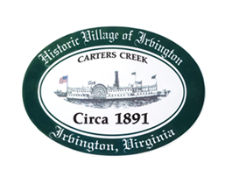

THE TOWN OF IRVINGTON
PC-TC WORKSHOP ON TOWN SEWER ALTERNATIVES AND NEXT STEPS
IRVINGTON BAPTIST CHURCH, IRVINGTON, VA
Tuesday, MARCH 12; 5:30PM

Preliminary Agenda 3/6/24 version

- Call to order – Tom Chapman

- Roll Call

- Public Comment

- Discussion of Alternatives, Issues and Next Steps

- Agreement on next Steps

- Adjournment

