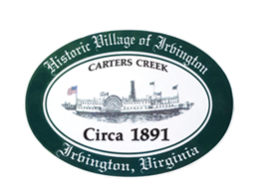

THE TOWN OF IRVINGTON

PLANNING COMMISSION REGULAR CALLED MEETING
Irvington Town Office, 4203 Irvington Rd., IRVINGTON, VA
TUESDAY, June 4, 2024; 6:30PM

Preliminary Agenda, Rev 1 6-3-24

- Call to Order

- Roll Call and Determination of Quorum

- Approve Minutes
- 5-7-24 Minutes approval

- Report From Chair- T. Chapman

- Public Comment

- Report from Zoning Administrator – Justin Nelson

  - CUP Notification Letters

- Old Business
  - CUP Pollard.2024 Discussion and vote
  - Accessory Dwelling Units- A. Pollard, Jr. and R. Fuller
  - VDOT Review of Transportation Section of Comprehensive Plan and Traffic Calming- Status Report- S. Strait.
  - Recommendation on Comprehensive Plan to Town Council- T. Chapman
  - Sign Ordinance Amendment, Status Report– D. Clarke/J. Taylor

- New Business
  - Reduction in the number of STRs – T. Chapman

- Next meeting
June 13, TC Regularly Scheduled Meeting 6:30 PM at IBC
July 2, 6:30, PC Monthly Meeting at Irvington Town Hall

- Roundtable

- Adjourn

