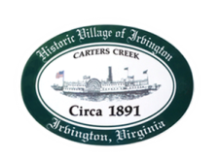
Town of Irvington Zoning Administrator Report
Prepared for Planning Commission & Town Council
Prepared For: July 2023 Regularly Scheduled Meetings
Staff Contact: Justin Nelson, Zoning Administrator

Zoning Permits:

2023-19, new expanded deck at 413 The Lane; 2023-20, re-issue expired permit for apartment space at 70 Rappahanock Rd; 2023-21 new signs for Accents, 4265 Irvington Rd

Miscellaneous:
Additional receipts received from Mr Fisher for removal of debris; site visit to tax map 34-10L (no 911 address at this time) on Old Mill Cove for new home; resubmit zoning application for same to PC; site visit to 277 Steamboat, no driveway work has begun.

