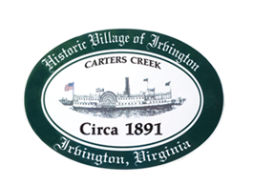

THE TOWN OF IRVINGTON

PLANNING COMMISSION REGULAR CALLED MEETING
Irvington Town Office, 4203 Irvington Rd., IRVINGTON, VA
Tuesday, December 5, 2023; 6:30PM

Preliminary Agenda

- Call to Order – T. Chapman

- Roll Call and Determination of Quorum – T. Chapman

- Approve Minutes
- 11/8/2023 Minutes approval – T. Chapman

- Report From Chair- T. Chapman

- Public Comment

- Report from Zoning Administrator – J.Nelson

- Old Business
  - Zoning Ordinance – Accessory Structures etc. – A Pollard, RFuller
  - Draft Comprehensive Plan Review status - T. Chapman
  - Sign Ordinance update – J. Taylor, D. Clarke

- New Business

- Round Table - All

- Next meeting:
January 2, 2024, PC Regularly Scheduled Meeting at Irvington Town Hall, 6:30 p.m.

- Adjourn

