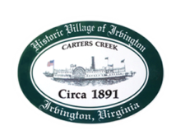
Town of Irvington Zoning Administrator Report
Prepared for Planning Commission & Town Council
Prepared For: May 2023 Regularly Scheduled Meetings
Staff Contact: Justin Nelson, Zoning Administrator

Zoning Permits:

#2023-14, new house on King Carter, tax map #33-238; 2023-15 dead tree in RPA;

Miscellaneous:
Additional receipts received from Mr Fisher for removal of debris; met with concrete contractor on Steamboat to finalize work, they started on Tuesday, May 2nd; site visit to 69 Chinis Lane for redevelopment in RPA; site visit to 207 Steamboat and to King Carter for tree work; completed DEQ Local Program Annual Implementation Report for the town.
Received complaint of STR’s advertising fire pits, went through all STR ads on Airbnb, identified 3 advertising fire pits and determined they are propane based, thus allowed.

