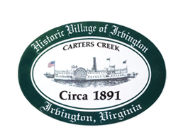

THE TOWN OF IRVINGTON
PUBLIC MEETING ON TOWN SEWER ALTERNATIVES
IRVINGTON BAPTIST CHURCH, IRVINGTON, VA
Tuesday, February 27; 5:30PM

Agenda

- Call to order – Tom Chapman

- Introduction

- Bowman Presentation of Preliminary Engineering Report (PER)

- Sewer Committee Presentation of Background and Next Steps

- Public Comment

- Adjournment

