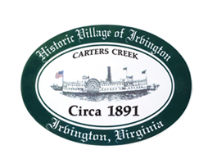

THE TOWN OF IRVINGTON
JOINT TOWN COUNCIL & PLANNING COMMISSION PUBLIC HEARING

IRVINGTON BAPTIST CHURCH, IRVINGTON, VA
Thursday, January 12, 2023; 5:30PM

Preliminary Agenda

Swearing in Ceremony of Town Council Members

- Call to order – Tom Chapman

- Roll Call of Planning Commission

- Roll Call of Town Council

- Approval of Agenda

- Playground Committee Presentation – G. del Rio

- Proposed CUP #2022.Honey
Proposed CUP #2022.TidesFarm
Proposed CUP #2022.Hillenbrand to operate a Short Term Rental to be located at 81 Carters Creek Road
Proposed CUP #2022.Kindle to operate a Short Term Rental located to be located at 277 Steamboat Road

- Adjournment

