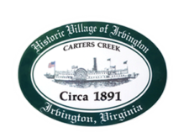
Town of Irvington Zoning Administrator Report
Prepared for Town Council
Prepared For: September 2023 Regularly Scheduled Meetings
Staff Contact: Justin Nelson, Zoning Administrator

Zoning Permits:

2023-24, new accessory structure/art studio at 370 King Carter Drive

Miscellaneous:
Additional receipts received from Mr. Fisher for removal of debris; site visit to storage of Christmas decorations; site visit to 187 York Road for potential pool installation.

Two site visits to the Aqua well on King Carter; one to verify DEQ clean up complete; one to walk proposed discharge pipe route, which will be on Tides Inn property line and discharge into Carter’s Creek

If the two STR CUP applications before you are approved, we are at our limit with two additional applications on hold.

AES engineering has begun survey work for sidewalks to run from Accents (florist shop) to Vineyard Grove

