Town of Irvington, Virginia
  - 2023 Comprehensive Plan – DRAFT July 21, 2023
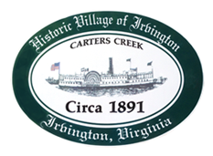

PLACEHOLDER COVER

Please Note:

The contents and layout of this draft document should be considered incomplete and subject to change. The purpose of this draft is to provide an update on our progress and an opportunity for feedback from the Town. We will continue to refine this draft over the coming months. Please let us know if you have any questions, suggestions, or concerns.

The Development Interest section is currently unchanged from the 2017 plan. We assume most of this information is outdated and will work to update it for the next draft.

The Goals, Objectives, Strategies, & Tactics section has been updated from the 2017 plan. If the Town is satisfied with this section, we will use it to inform the incomplete Future Land Use section, its corresponding map, and the Implementation section.

Thank you very much for your consideration.

Alan Simpson
Will Cockrell
EPR, P.C.
July 21, 2023

Acknowledgements

Town Council
Julie Harris, Mayor
Jackie Brown
Gabe Del Rio
R. Wayne Nunnally
Dudley Patteson
Judith Penniman
Philip A. Robinson

Planning Commission
Tom Chapman, Chair
Ruth Fuller
Dawn E. Fowle
David Clarke
Lee Hood Capps
Albert Pollard, Jr.
Jeremy Taylor

Staff Support
Justin Nelson, Zoning Administrator
Laurel Taylor, Town Clerk, FOIA Officer, Notary

Consultant
EPR, P.C.

Table of Contents

Vision Statement for the Town of Irvington x
Introduction x
Purpose x
Authority x
Town Boundary x
Public Input x
Community Survey x
Public Meetings x
Key Takeaways x
Background x
Population and Age x
Housing Characteristics x
Key Takeaways x
Map 1: Town of Irvington Regional Setting x
Historic and Cultural Resources x
Regional Setting x
History x
Arts, Culture, and Events x
Key Takeaways x
Map 2: Town of Irvington Historic District x
Map 3: Hurricane Storm Surge Risk x
Environmental Resources x
Coastal Waters and Wetlands x
Carter’s Creek x
Flood-Prone Areas x
Map 4: 100-Year FEMA Floodplain x
Wetlands x
Water Access & Use x
Topography & Soils x
Key Takeaways x
Existing Land Use and Zoning x
Existing Land Use x
Current Zoning x
Key Takeaways x
Map 5: Existing Land Use x
Map 6: Existing Zoning Districts x
Development Interest x
Approved Development x
Downtown Development Proposal x
Planned Unit & Clustered Development x
Key Takeaways x
Economy x
Existing Business Mix x
Town Employment x
Income x
Key Takeaways x
Community Facilities x
Town Office x
The Commons / North Commons x
Waterfront x
Utilities x
Other Facilities x
Key Takeaways x
Transportation x
Roadway Classifications x
Map 7: Roadway Classifications x
Roadways and Traffic Volumes x
Alternative Transportation Options x
Key Takeaways x
The Plan x
Goals x
Objectives & Strategies x
Future Land Use x
Map 8: Future Land Use x
Implementation x
Appendix A: 2022 Survey Results x

Vision Statement for the Town of Irvington

Looking forward, Irvington will continue to thoughtfully weave together its natural and historic assets, present charm and future growth for the benefit of the town. Irvington began as a steamboat port on Carter’s Creek in 1873 and is now a picturesque, historic village known for its strong sense of community, breathtaking scenery, recreational water activities. Residents and visitors stroll our Main Street, meet in delightful restaurants and shops, gather on the Commons for Farmer’s Markets and concerts and take pride in our traditional July 4th parade. In all this, they experience a peaceful, connected and deeply satisfying way of life. On the water, the renowned Tides Inn lends grace and serenity to Irvington while close by busy marinas, boatyards, a yacht club and water activities of all kinds flourish on the creek.

We are stewards of all this beauty and bounty and we envision Irvington growing and evolving in ways that enhance our community life. In our residential area we encourage open green space, limited density and compatible architecture to maintain our cherished rural village character. Recognizing our attraction for retirement and resort living as well as our appeal to young families seeking a close-knit community, we support local small businesses as they anticipate emerging town and visitor needs and the continuing success of the Tides Inn. Our water is our jewel and we will continue to protect Carters Creek and the Chesapeake Bay watershed environment for future generations to enjoy. We also support redevelopment of a working waterfront and innovative efforts to expand public access to the water.

Envisioning the future in these ways respects Irvington’s natural setting, historic appearance and small-town character while encouraging its recognized entrepreneurial spirit and potential. It also continues the town’s long tradition of actively shaping its own destiny since incorporation in 1955. Preserving our community through purposeful change assures all of us that Irvington will be as exceptional tomorrow as it is today.

[Adopted by the Irvington Town Council INSERT DATE]

Introduction

Purpose
The Comprehensive Plan guides the physical development of the Town of Irvington to 2033. It addresses the entire town and is intended to positively influence all the physical elements which make up its form. Towards this end, the overriding purpose of the Plan is to encourage the continued development of a safe, healthy, and prosperous community by offering a distinctive “vision” for the town.

The Comprehensive Plan is the most critical public document for orchestrating growth and development in the years ahead. It establishes goals, objectives, and strategies to guide civic and public activities related to land use and resource utilization for the next ten years.

Though the Plan outlines a long-term vision, it is not static. The Comprehensive Plan is meant to be a “living document” – continually reviewed and periodically updated based on changing conditions and shifting resources. Additionally, the Comprehensive Plan is only as good as the tools and actions utilized in implementing the Plan. It comes to life as action plans and specific project plans are developed and implemented.

Authority
Chapter 22 of Title 15.2 of the Code of Virginia grants local governments distinct powers and responsibilities to plan for future growth and regulate land use within their jurisdictions. One primary way this is accomplished is through the Comprehensive Plan.

Section 15.2-2223 of the Code of Virginia mandates that:

“The local planning commission shall prepare and recommend a comprehensive plan for the physical development of the territory within its jurisdiction and every governing body shall adopt a comprehensive plan for the territory under its jurisdiction.”

Irvington’s Planning Commission is responsible for preparing the Plan and recommending the Plan for adoption by the Town Council.

Town Boundary
It is typical for there to be confusion as to the exact location of a municipality’s corporate limits. This can be true of those residing inside a given municipality and outside its corporate limits. Readers of this Comprehensive Plan should review the maps herein to precisely delineate the town’s boundary. It should be noted that the Irvington Postal Zip Code (22480) encompasses a geographic area that extends well beyond the town’s boundary. While many of the residents living outside of the town but residing within the 22480 Zip Code might identify with Irvington and take an interest in its affairs, the data, descriptive information, and planning discussions contained in this Comprehensive Plan are limited to matters pertinent to Irvington as established by the Town Charter and the Commonwealth of Virginia.

Background

Population and Age
According to the U.S. Census Bureau, Irvington experienced an increase (9.26%) in its total population between 2010 and 2020. As seen in Figure 1, this increase in population exceeds the decline countywide (4.14% from 2010 to 2020).

As a waterfront community, the town has a more significant percentage of part-time residents than most other municipalities in Virginia and the Northern Neck region. Planning Commission members cite a gradual transition in recent decades from a majority of full-time residents to more part-time and seasonal residents. Lancaster County’s tax records confirm this by showing that of all town residences, roughly half are under the possession of an owner whose mailing address is somewhere other than Irvington.

Though Irvington’s population swells during the warm weather months, any temporary increase would not be depicted in a year-round population count.

Irvington is also prone to rapid turnover as a destination for retirees and second homes. According to the National Institute on Aging’s Health and Retirement Study (2015), retired individuals will, on average, live an additional seventeen to twenty years after retirement.

The Weldon Cooper Center for Public Services estimates that over the next seventeen years, the county is expected to steadily undergo a gradual population decline, projecting a population of 9,826 by 2040. Since Irvington’s population is mainly seasonal, population fluctuation at the County and Regional levels will likely not significantly impact the town. Whereas the county may be subject to the ebbs and flows of migration and natural increase, Irvington is greatly affected by in-migration, out-migration, and full-time versus part-time residency.

Figure 1: Population Change (2010-2020)

 | 2010 | 2020 | Change (2010-2020) | Percent Change (2010-2020)
Irvington | 432 | 474 | +42 | +9.26%
Lancaster County | 11,391 | 10,919 | -472 | -4.14%
Northern Neck Planning District Commission | 50,429 | 50,158 | -271 | -0.58%
Source: U.S. Census Bureau Decennial Census

Of the population changes predicted for Lancaster County and the Northern Neck region, the most significant influence will be on persons of retirement age. An Estimate of Projected Age in Virginia based on the 2010 Census published by the Weldon Cooper Center in 2012* indicated that between 2020 and 2030, the Northern Neck region will see a 24% increase in the population aged 65 and over. Lancaster County is predicted to experience similar growth (22%) in the same cohort. Additionally, 20% and 23% increases are projected in the cohort of persons aged 40 to 49 as the millennial generation reaches middle age in the Northern Neck region and Lancaster County, respectively. *Note that the Weldon Cooper Center has not yet released population projections by age based on the 2020 Census as of May 2023.

Figure 2: Population Projections (2030-2050)

 | 2030 | 2040 | 2050 | Change (2030-2040) | Change (2040-2050)
Lancaster County | 10,297 | 9,826 | 9,502 | -4.57% | -3.30%
Northern Neck Planning District Commission | 49,171 | 48,843 | 49,245 | -0.67% | +0.82%
Source: U.S. Census Bureau Decennial Census, Weldon Cooper Center for Public Service

As of the 2021 American Community Survey, most of the town’s population was concentrated in the three cohorts aged 45 to 54, 55 to 65, and 65 years and over. No individual age cohort under 45 makes up more than 5% of the population in the town. Figure 3 depicts the townwide age distribution using American Community Survey estimates from 2011 and 2021.

The Town and County are experiencing declines in the youth and middle-aged segments of the population, with a more dramatic decline occurring in Irvington. As of 2021, the median age for the town was 58.7 years, compared to 57.1 years in the county. By 2030, the population distribution of Lancaster County is expected to resemble an inverted top, with those aged 65 to 74 comprising the largest proportion of the population and those aged 25 to 34 the least.

Figure 3: Population Distribution by Age (2011-2021 Estimates)

Source: U.S. Census Bureau American Community Survey 5-Year Estimates

There were 213 households in Irvington in 2021, a significant number of which were occupied by householders 65 or older. Figure 4 emphasizes how few households in Irvington are comprised of families with children.

Figure 4: Households & Families (2011-2021 Estimates)

 | 2011 | Margin of Error (2011) | 2021 | Margin of Error (2021) | Change (2011-2021) | Percent Change (2011-2021)
Total Households | 253 | ±65 | 213 | ±57 | -40 | -15.81%
Family Households | 186 | ±57 | 152 | ±49 | -34 | -18.28%
Nonfamily Households | 67 | ±35 | 61 | ±33 | -6 | -8.96%
Households with one or more people under 18 years | 49 | ±5 | 22 | ±12 | -18 | -45%
Households with one or more people 60 years and over | 124 | ±17 | 123 | ±17 | -1 | -0.8%
Average Household Size | 1.92 | ±0.21 | 1.95 | ±0.26 | +0.03 | +1.6%
Average Family Size | 2.25 | ±0.26 | 2.22 | ±0.39 | -0.03 | -1.33%
Source: U.S. Census Bureau American Community Survey 5-Year Estimates

Housing Characteristics

Figure 5: Housing Occupancy (2011-2021 Estimates)

 | 2011 | Margin of Error (2011) | 2021 | Margin of Error (2021) | Change (2011-2021) | Percent Change (2011-2021)
Total Housing Units | 341 | ±72 | 351 | ±61 | +10 | +2.93%
Occupied Housing Units | 253 | ±65 | 213 | ±57 | -40 | -15.81%
Vacant Housing Units | 88 | ±35 | 138 | ±39 | +50 | +56.82%
For Rent | 0 | ±95 | 12 | ±14 | +12 | -
For Sale Only | 0 | ±95 | 5 | ±8 | +5 | -
Seasonal, Recreational, or Occasional Use | 78 | ±35 | 99 | ±33 | +21 | +26.92%
All Other Vacant Units | 4 | ±8 | 17 | ±16 | +13 | +325%
Homeowner Vacancy Rate | 0 | ±16.6 | 2.5 | ±4.2 | +2.5 | -
Rental Vacancy Rate | 0 | ±43.3 | 37.5 | ±33 | +37.5 | -
Source: U.S. Census Bureau American Community Survey 5-Year Estimates

Figure 6: Housing Units (2021 Estimates)

 | Irvington | Margin of Error | Percent | Lancaster County | Margin of Error | Percent
Total Housing Units | 351 | ±66 | - | 7,454 | ±66 | -
Single-Family | 337 | ±64 | 96% | 6,296 | ±64 | 87%
Attached, Multifamily, or other | 14 | ±13 | 4% | 1,158 | ±13 | 13%
Source: U.S. Census Bureau American Community Survey 5-Year Estimates

Figure 5 shows that from 2011 to 2021, available housing increased by approximately ten units. The 2011 American Community Survey determined that the number of occupied units has declined by 40 since 2011. Note that for a residence to be considered occupied, the person or family must live and sleep in the home more frequently than anywhere else. Many homes in Irvington are not the owner’s primary residence. From 2011 to 2021, the number of residences considered vacant (defined by the Census Bureau as an occupiable dwelling for which no Census form was returned and appeared vacant, as verified by a Census enumerator) increased by 50.

The above figures show that most vacant housing units fall under seasonal, recreational, or occasional use categories. Figure 6 depicts the 2021 distribution of housing units in Irvington and Lancaster County by type. As of the 2021 estimate, there were 351 housing units in Irvington, a minor increase since 2011. Of the 351 units, 337, or 96%, are single-family homes. Lancaster County is primarily dominated by single-family homes as well, but not by as much, with 87% of units designated as single-family.

Figure 7: Median Value of Owner-Occupied Housing, 2021 Estimates

Source: U.S. Census Bureau American Community Survey 5-Year Estimates

As seen in Figure 7, housing values are higher in Irvington than the Lancaster County average. The median value of owner-occupied housing in the town is $275,000, according to 2021 estimates. This is far higher than the surrounding area, as median home values in Kilmarnock and White Stone are $203,500 and $152,500, respectively. The countywide median home value is $241,400.

Note: It is important to point out that the margin of error for American Community Survey data at the town level is significantly higher than the reported margins of error at the County and State levels. Beginning with the 2010 Census, the U.S. Census Bureau does not collect the level of detailed data previously gathered via the “long form” Census questionnaire. Before the 2010 Census, the Census Bureau shifted to collecting much of the household and economic data via the more frequently conducted American Community Survey (ACS) process. The ACS methodology is based on smaller sample sizes and consequently has higher margins of error, a fact that is particularly pronounced for small localities. It is, therefore, crucial to emphasize that the American Community Survey numbers reported in this plan are estimates only and are meant to serve only as references to guide future planning efforts.

Key Takeaways
Irvington has experienced notable demographic and housing changes over the past decade. The population increased by 9.26% between 2010 and 2020, defying a countywide decline. This growth, however, is marked by a transition to more part-time and seasonal residents, an increasing proportion of retirees, and rapid turnover. The town’s younger population is shrinking, with no individual age cohort under 45 making up more than 5%. Meanwhile, the town’s household composition is dominated by older adults, with a notable scarcity of households comprised of families with children. The housing market reflects these trends, with a minor increase in housing units, a decline in occupied units, and a rise in vacant, primarily seasonal properties. Single-family homes dominate the housing landscape, and home values in Irvington are significantly higher than the Lancaster County average. These trends underscore Irvington’s unique position as a waterfront community, attracting a predominantly older and part-time population, a dynamic that will likely continue to shape the town’s demographics and housing market.

Map 1: Town of Irvington Regional Setting
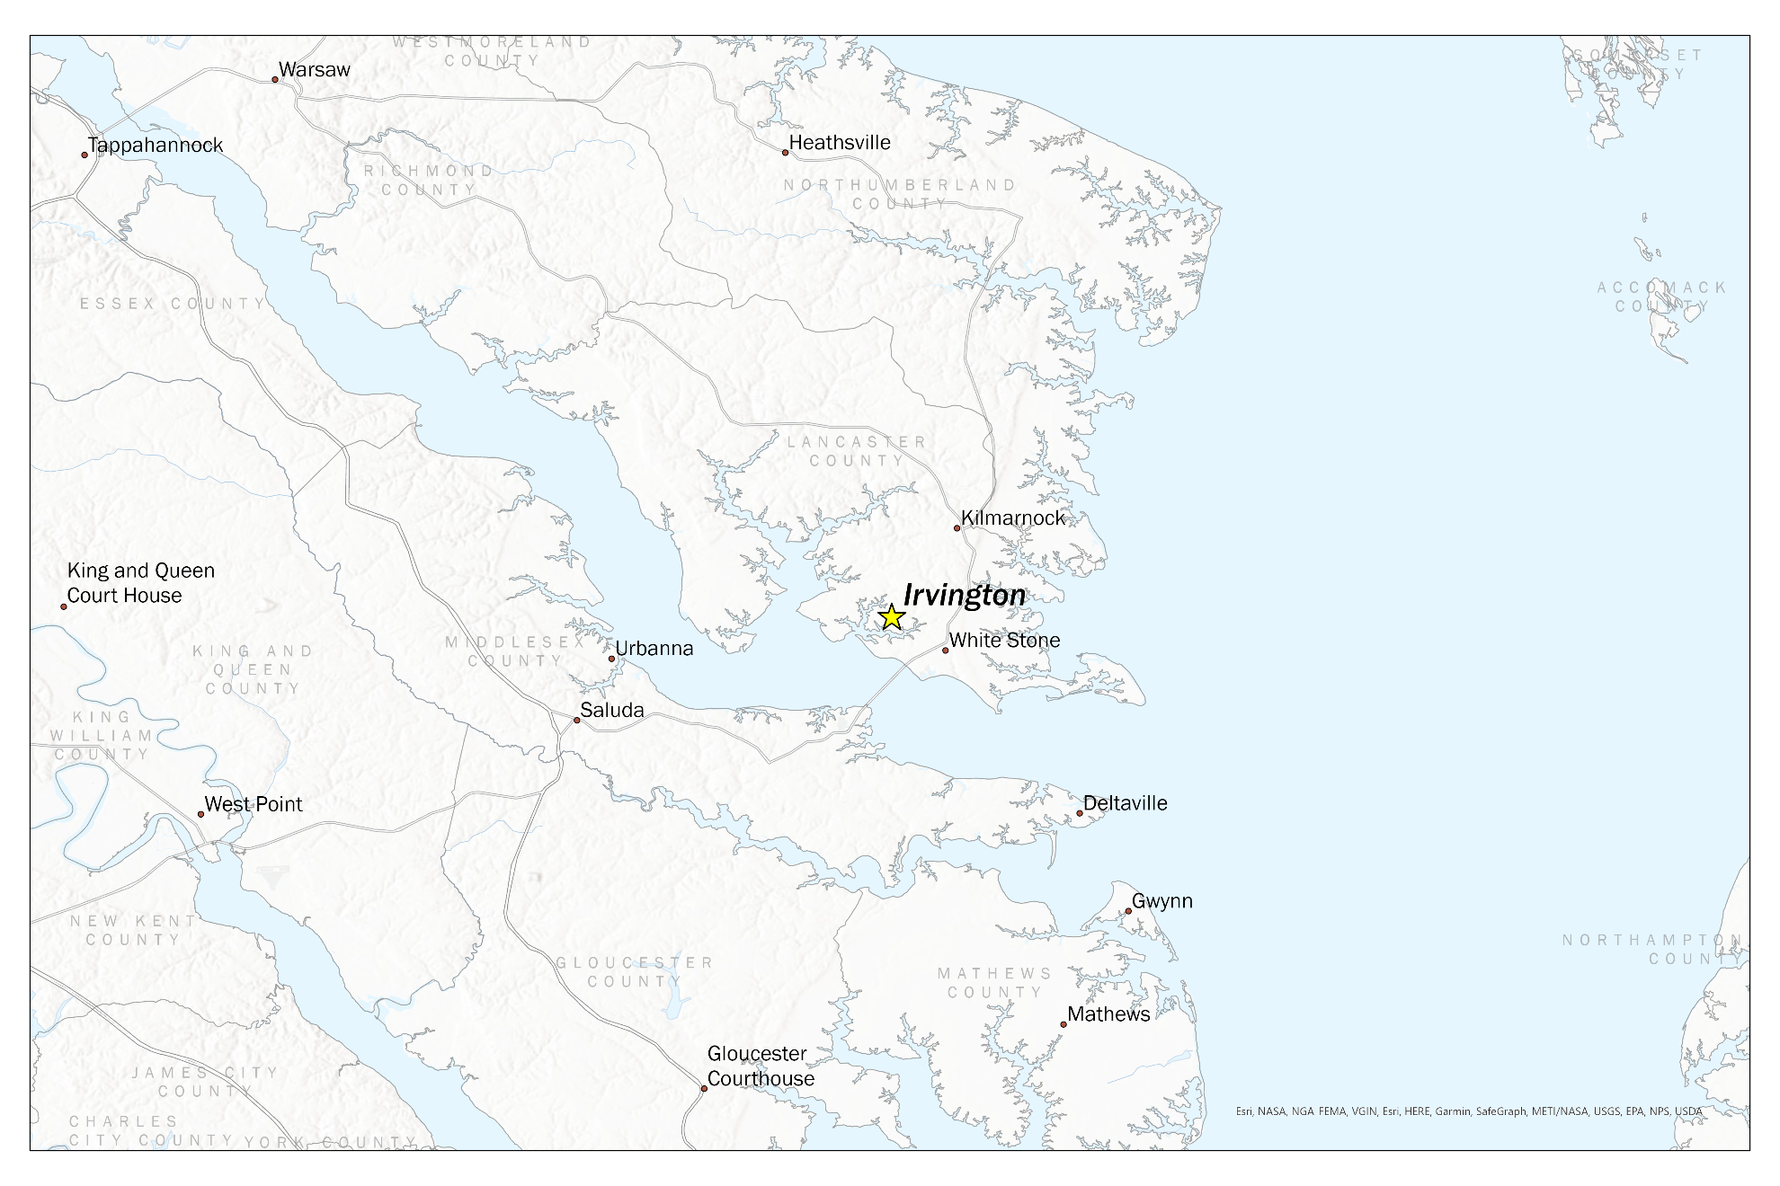

Historic and Cultural Resources

Regional Setting
The Town of Irvington is located in Lancaster County, Virginia, in the southeastern portion of the Northern Neck, a peninsula bounded by the Potomac River to the north, the Chesapeake Bay to the east, and the Rappahannock River to the south. Irvington sits on the shores of Carter’s Creek, a tributary of the Rappahannock River.

History
Irvington’s identity is strongly tied to its location on the water. The area was initially established as Carter’s Creek Wharf in honor of the surrounding waterway. The original wharf community was largely isolated from surrounding localities due to poor road conditions. As a result, water transport was the only practical way to reach the community before the introduction of paved roads and bridges in the first quarter of the 20th century. Residents relied on ferry boat service to cross the Rappahannock River.

This land-based isolation was significantly mitigated by the success the town found during the steamboat era. At its height, steamboats to and from Baltimore and Norfolk would stop in Carter’s Creek up to eight times per week. As a result, support industries and residential dwellings began to develop along the town’s then-commercial center, present-day Steamboat Road. The village quickly grew into Lancaster County’s largest community and was renamed Irvington in 1891 after local resident Captain Levin Handy Irving to alleviate confusion with postal delivery.

The decline of the steamboat industry, an unfortunate fire in 1917, and a major storm in 1933 resulted in the loss of many of the town’s water-based commercial enterprises and original architecture. The town’s remaining historic architecture is included within the boundaries of the Irvington/Carter’s Creek Historic District, as shown in Map 2. The district includes the town’s first public schoolhouse, which now functions as the popular Hope and Glory Inn.

Arts, Culture, and Events
Present-day Irvington continues to benefit from its idyllic location near the Chesapeake Bay and has experienced a resurgence as an attractive tourist destination. Irvington is probably most well-known as the location of the Tides Inn (established in 1947); however, its history as a thriving steamboat community lives on through the Steamboat Era Museum. The museum was established to preserve the legacy of steamboats in the town and throughout the Chesapeake Bay. From its grassroots inception in 1999 to its opening day in 2004, the museum has become a unique treasure for the local community and visitors. The Steamboat Era Museum is the only museum dedicated to the history of steamboats on the Chesapeake Bay.

In addition to the town’s historic assets, Irvington offers popular local events that attract visitors from around the region. The Irvington Commons is centrally located along King Carter Drive and serves as the town’s hub of activity. The Irvington Village Improvement Association (VIA) sponsors and implements most of the community events held there.

Irvington Farmers Market
The Irvington Farmers Market is held every first Saturday from May through November at the Irvington Commons. The market attracts over 100 vendors from the Northern Neck region and beyond who display artisan-made crafts, breads, cheeses, furniture, jewelry, and artwork. The Irvington Farmers Market was voted Best Farmer’s Market on Virginia’s East Coast by Virginia Living Magazine from 2012 through 2019.

Typhoon Nationals
Irvington is home to the nation’s largest fleet of Cape Dory Typhoons, and the Rappahannock River Yacht Club hosts an annual regatta in June that draws entrants from a wide geographic area.

Annual 4th of July Parade
Irvington’s annual 4th of July parade winds down King Carter Drive and continues along Irvington Road, drawing visitors from across the region. The parade typically includes over 100 entries and is followed by an antique car show on the Irvington Commons, with over 75 models dating back to the early 1900s. Locals favorably refer to the event as a “Hometown Parade” reminiscent of a scene by Norman Rockwell.

U. S. Air Force Band Concert
The premier event occurs in the summer, usually around the 4th of July, when VIA presents the USAF Heritage of America Band. With 40-plus musicians, this renowned group brings marches, show tunes, orchestral, and jazz numbers to a huge crowd. Held on the Commons, the event provides the perfect setting for family picnics and gatherings of friends.

Annual Halloween Costume Contest
The annual event features prizes for the best costumes for children under 13.

Annual Turkey Shoot Regatta and Turkey Trot
Irvington marks the fall with two region-wide community events. In early October, the Rappahannock River Yacht Club, Yankee Point Racing and Cruising Club, and Rappahannock Yachts host the Hospice Turkey Shoot Regatta, a fund-raising event with all proceeds going to local Hospices. In November, the VIA co-sponsors the annual Turkey Trot, which includes two- and five-mile runs and a 100-yard Tot Trot for children.

Annual Christmas Holiday Festival
Each year brings Christmas caroling and the blessing of the Town Christmas Tree on Christmas Eve.

Key Takeaways
Irvington’s identity is deeply rooted in the steamboat era and the town’s development as a close-knit waterfront community. Town leaders and citizens have worked diligently to preserve this original village character, which is reflected in the town’s local events, most of which take place at the Irvington Commons and emphasize community and small-town hospitality. Preserving and enhancing the town’s village aesthetic and historic assets are essential to residents and must remain a high priority in the future.

Map 2: Town of Irvington Historic District
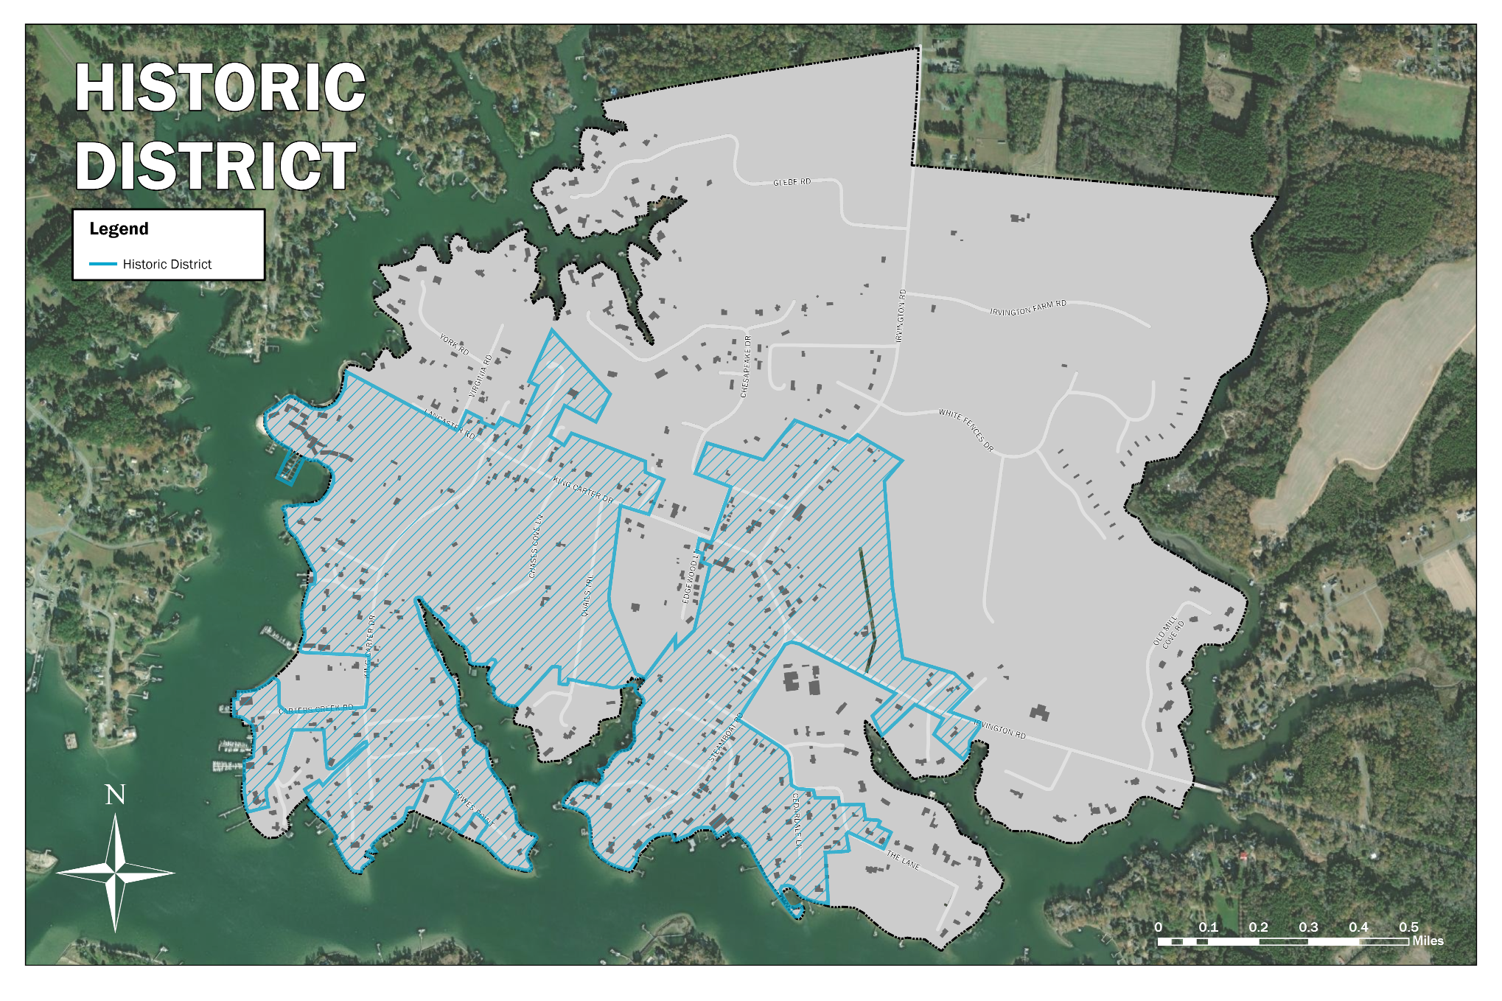
Source: Virginia Department of Historic Resources

Environmental Resources

Coastal Waters and Wetlands

Carter’s Creek
Carter’s Creek, the last major tributary along the Rappahannock River’s north bank, is Irvington’s crowning jewel. Irvington’s economy and quality of life depend on the creek’s locational advantage. The geography of the creek flowing to the Rappahannock River is a direct route to the Chesapeake Bay with the benefit of being set back from the crosshairs of coastal storms and tidal surges.

Flood-Prone Areas
The peninsula that is the Town of Irvington, demarcated by the tidal waterways of Carter’s Creek, has several minor flood-prone areas of note. These flood-prone areas are defined by the 100-year flood plain as defined by the Federal Emergency Management Agency (FEMA). However, the 100-year flood plain does not extend far inland into the town’s residential areas. About 59 of the town’s 957.5 acres of land area lie within the 100-year flood plain (roughly 6%).

The largest area within the flood plain is in the southwestern portion of the town. The yacht club, marina, and a sliver of residential area in the southwest corner are in the 100-year floodplain. Other flood-prone areas extend from the creek in the northwest part of the town and along the eastern branch of Carter’s Creek. Subject to inundation from a 100-year flood, these areas can experience damage resulting in expensive repairs to structures, loss of use of structures, inoperable septic systems, and water contamination. Exacerbated by existing development in flood-prone areas, Irvington should continue to work with regulatory agencies to restrict development in the 100-year floodplain.

Areas that flood from storm surges are comparable to areas that flood from 100-year storms, given Irvington’s tidal location. A Category 1 hurricane would roughly push water from the Bay and Rappahannock River to the same point as a 100-year storm. Map 3 depicts local Category 1-4 hurricane storm surge areas, with red areas representing Category One hurricanes and purple areas representing Category 4 hurricanes. Map 4 shows the FEMA-delineated 100-year flood plain.

Map 3: Hurricane Storm Surge Risk
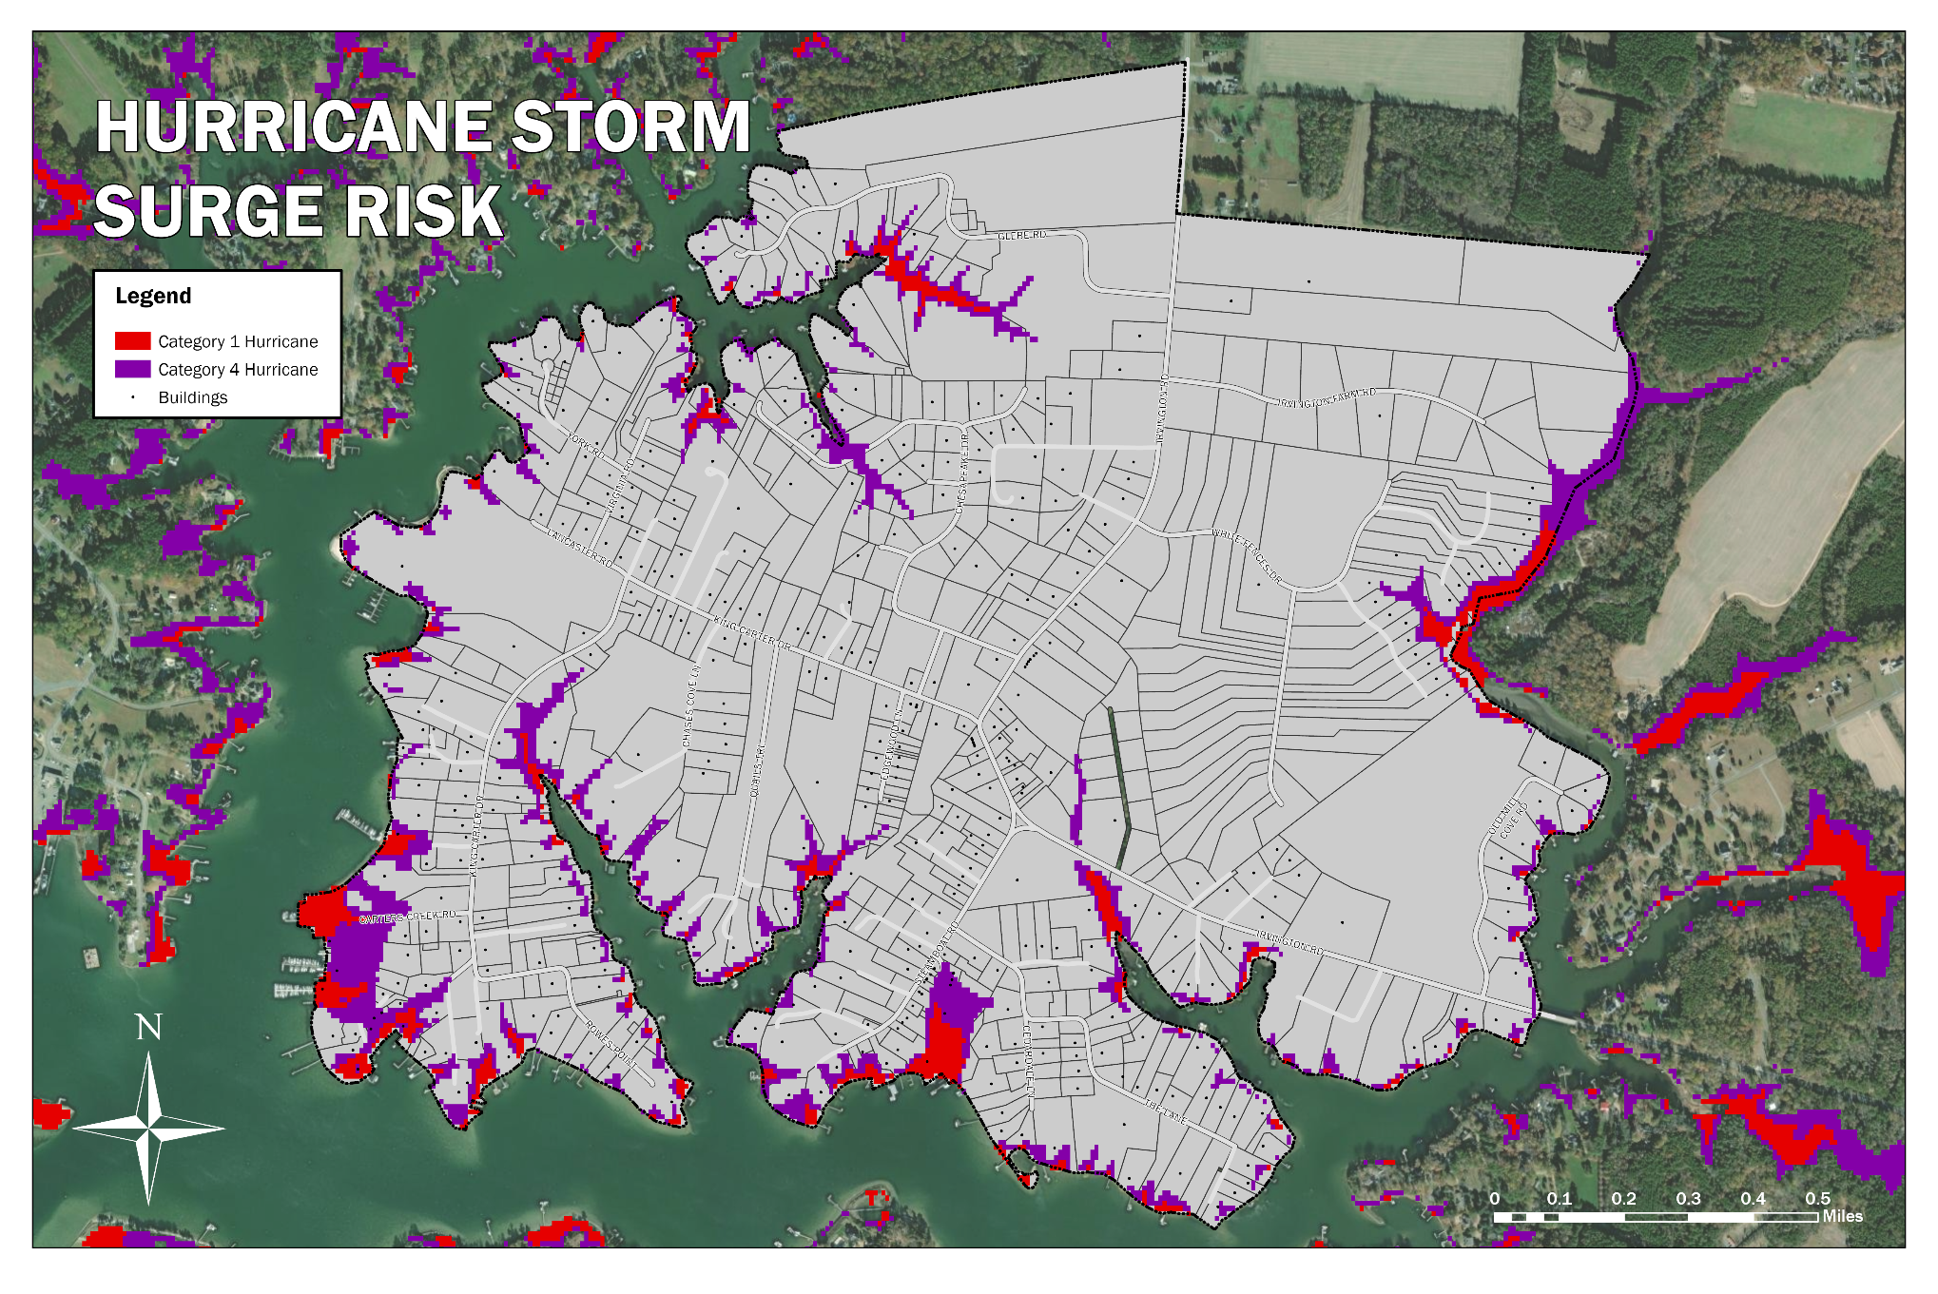
Source: NOAA

Map 4: 100-Year FEMA Floodplain
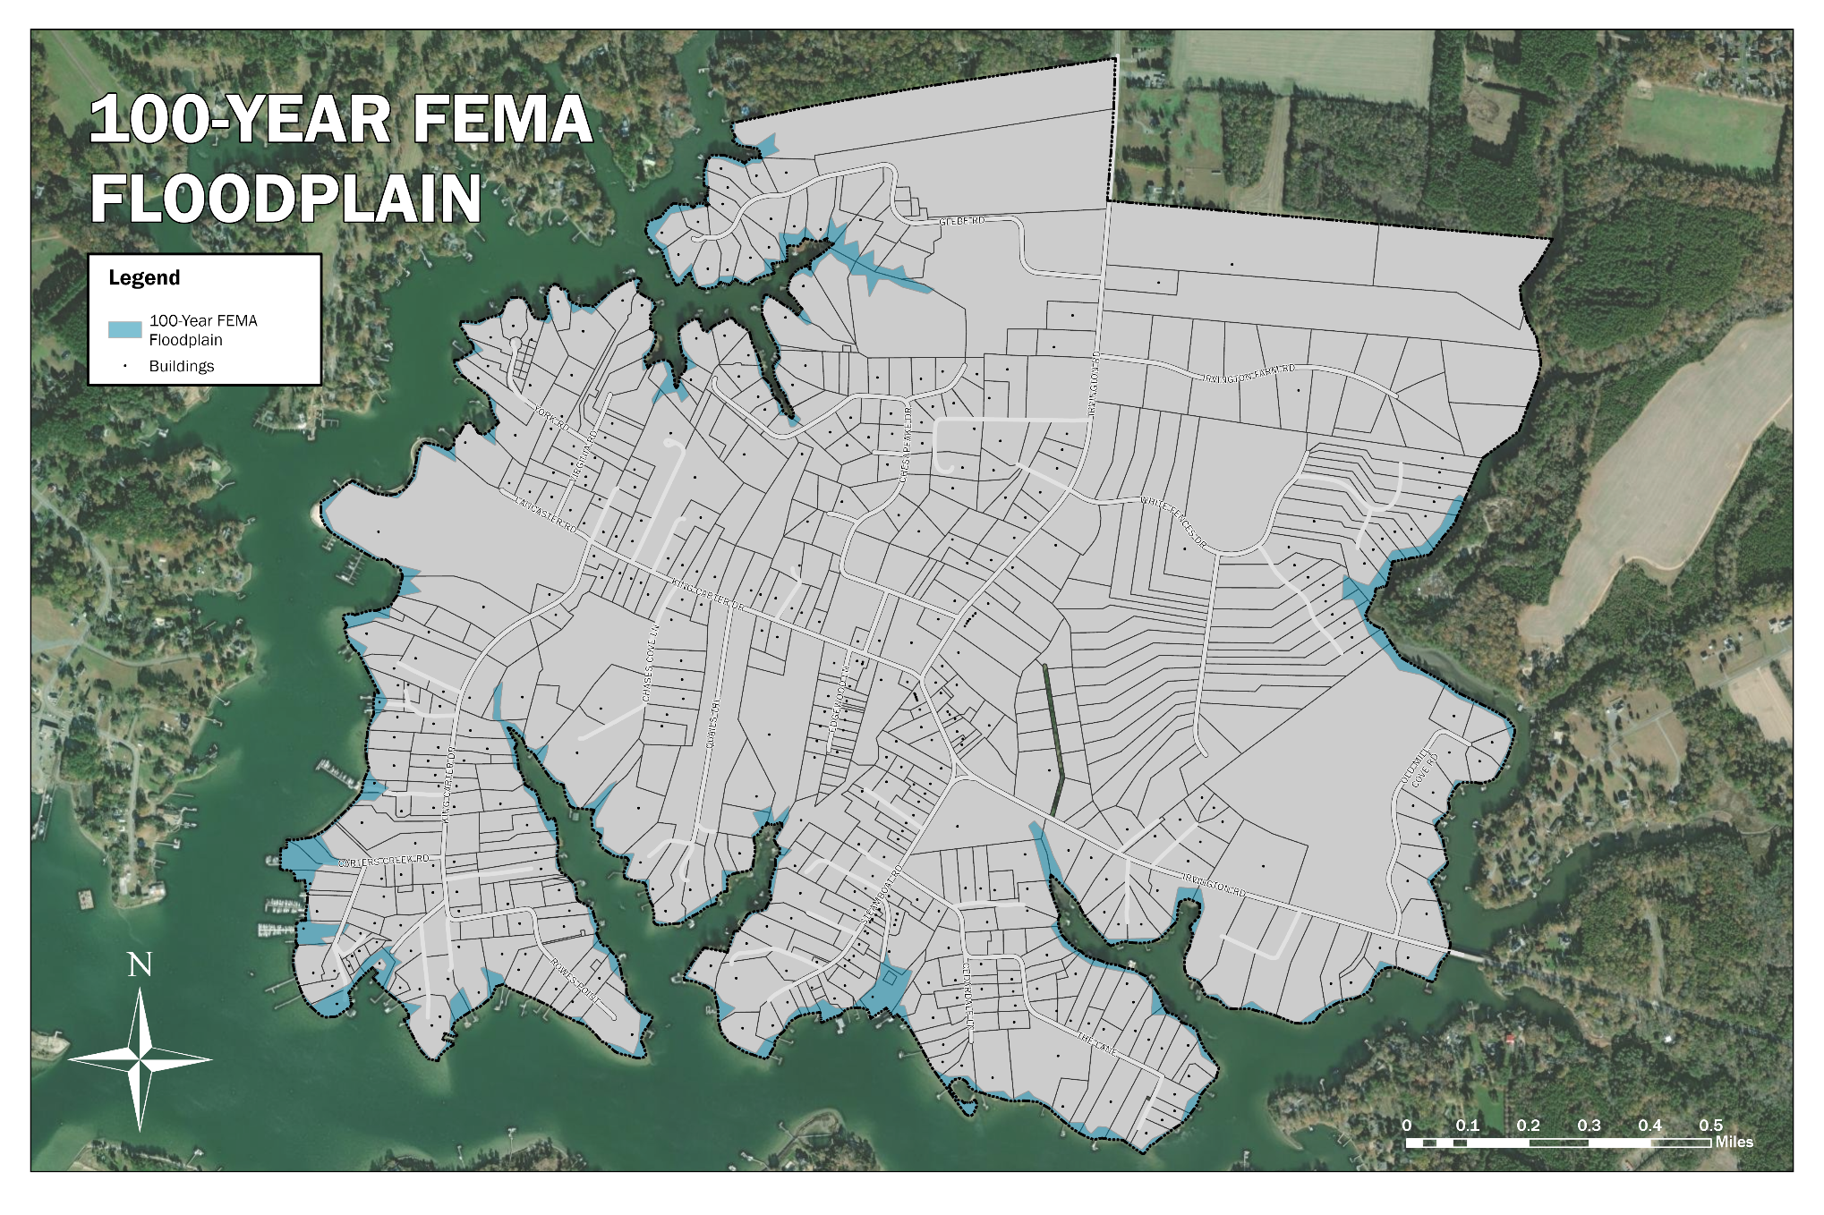
Source: FEMA

Wetlands
The United States Fish and Wildlife Service has defined wetlands as land transitional between terrestrial and aquatic systems where the water table is usually at or near the surface or the land is covered by shallow water. Irvington contains minimal tidal and non-tidal wetlands. Considering the amount of tidal water that envelops Irvington, the town has surprisingly few marshy or estuarine environments. There is one small freshwater wetland between two ponds in the northeastern corner of the town and a few small pockets of tidal wetlands along the shore scattered about.

No matter how small, wetlands are an ever-vital natural resource that benefits people and the environment. They provide aesthetic, recreational, and economic benefits to communities. Fish rely on wetlands for spawning and nursery grounds, waterfowl for feeding sites, birds for nesting habitat, and wildlife for a home. Wetlands also allow for groundwater recharge, flood control, pollutant absorption, and sediment retention, especially during stormwater runoff. Therefore, it is of utmost importance for Irvington to preserve wetlands endemic to the town.

Topography & Soils
The topography of Irvington is such that it is an ideal location for coastal water access and development of all types. Much of the shoreline rises fairly quickly from sea level to at least 20 feet above sea level. Only in certain areas to the south and southwest does the shore not rise rapidly. Away from the immediate shore, the town is relatively flat, with nearly unnoticeable changes in elevation.

While it is nearly impossible to be more than a half mile from water anywhere in Irvington, less than a quarter of the town’s total land area rests below 20 feet above sea level. A majority of the southern and western half of the town is between 20 and 30 feet above sea level, and the northern and eastern half is mostly between 30 and 35 feet above sea level. The flat nature of the town’s inland topography can inhibit stormwater runoff following moderate or significant rain events. Areas along the shore with steeper slopes drain more quickly into Carter’s Creek. However, quick runoff along the shore adds to coastal erosion problems.

The shoreline is made up of steep sandy land where the land rises more dramatically and sloping sandy land where it is a more modest slope. In the interior of Irvington, the soil is prime for agriculture and development. The soil is predominantly a level and gently sloping Sassafras fine sandy loam that drains well and represents two to three feet of separation between the surface and the water table below.

Trees
A casual survey of trees in Irvington show that there are many remarkable specimins in size and diversity as compared to surrounding towns of Kilmarnock, White Stone and others. These trees add a significant (if understated) value to the ambiance of the town. (As a thought experiment, imagine if all of Irvington’s trees over 50’ tall were replaced with Bradford Pears).

Key Takeaways
Irvington’s geography, marked by Carter’s Creek and a strategic position along the Rappahannock River, offers significant economic benefits and environmental challenges. The town’s relative protection from coastal storms and tidal surges and its direct route to the Chesapeake Bay contribute to its quality of life and economy. However, Irvington’s minor flood-prone areas, constituting about 6% of its land, present a potential threat to structures and the environment. The town should continue to restrict development in these areas. Despite being engulfed by tidal waters, Irvington’s wetlands are sparse, highlighting the need for their preservation due to their numerous environmental benefits. The town’s topography and soil condition, ideal for coastal water access, development, and agriculture, further emphasize the importance of careful environmental management.

Existing Land Use and Zoning

Existing Land Use
Irvington’s land use patterns emerged because of its role as a waterfront community developed around the boating and fishing industry. Later development was characterized by residential and recreational use, including the continued growth of the Tides Inn. Many of the industrial uses have declined over the years, reflecting a decline in the fishing, oystering, and crabbing industries. The town has traditionally had two commercial hubs, a larger one primarily centered around the intersection of Irvington Road and King Carter Drive and a much smaller hub at the end of Steamboat Road.

As shown in Figure 8 and on the Existing Land Use Map, the town’s predominant land use is single-family detached residential, making up 388.15 of the town’s 969.7 acres, or 41.7% of the land. Agricultural use has dwindled to 54.35 acres, 19.92 of which are placed in a land land conservation easement on the north end of Irvington. Vacant or undeveloped land makes up 337.59 acres or 34.8% of the town. This land is considered developable unless impeded by environmental factors such as wetlands, steep slopes, etc. However, most of the developable land in Irvington is not significantly constrained by these factors. Therefore, the town has significant development potential.

As referenced earlier, land for Industrial use has shrunk significantly over the years, as has the amount of land dedicated to boat sales and repairs with at least two boatyards converting to residential use in recent years. Land designated for lodging use has grown, mainly through the continued growth of the Tides Inn complex on the western edge of town and the creation of the Vineyard Tents development (most of which is in vacation rental use) on the eastern edge of town. Lodging represents 71.22 acres of land or 7.3% of the town’s land mass, making it the third-largest land use category.

Figure 8: Existing Land Use

Land Use Classification |  | Acres | Percent
Residential | Single-Family Detached | 388.15 | 41.7%
 | Single-Family Attached (Townhouses) | 0.30 | 0.0%
Commercial | Business/Professional | 10.59 | 1.1%
 | General Commercial | 0.67 | 0.1%
 | Lodging | 71.22 | 7.3%
 | Recreation | 8.61 | 0.9%
 | Retail & Service | 10.89 | 1.1%
Industrial | Industrial | 12.41 | 1.3%
Public and Semi-Public | Community Facilities | 9.59 | 1.0%
 | Institutional | 8.72 | 0.9%
 | Places of Worship, Cemeteries & Lodges | 6.38 | 0.7%
 | Rights of Way | 33.10 | 3.4%
 | Utilities | 1.36 | 0.1%
Agricultural | Agricultural | 34.43 | 3.6%
Undeveloped | Agricultural in Conservancy | 19.92 | 2.1%
 | Vacant/Undeveloped | 337.59 | 34.8%
Total Land Area |  | 969.70 | 100%
Source: EPR Analysis (2023)

Current Zoning
The Existing Zoning Districts Map shows the Town’s current zoning districts. For the most part, it reflects the Existing Land Use Map. However, it also sets a clear course for Irvington by indicating that the more extensive undeveloped tracts of land in the northern and eastern portions of the town are to be developed at a lower density (one dwelling unit per 2 acres of land) than the existing residential portions of town (one dwelling unit per 1 acre of land for new development). This delineation serves to preserve the small-town and rural atmosphere in Irvington, but it also has the potential to slow the development of the remaining undeveloped land.

Key Takeaways
Irvington’s current land uses reflect a community geared towards people with a second home or those of retirement age who have gravitated to its waterside location and village feel. With limited general commercial and retail uses in Irvington, residents depend on neighboring commercial and retail services in nearby Kilmarnock and White Stone. As the Town looks to the future, it must balance preserving its village feel and managing the development of its remaining undeveloped land.

Map 5: Existing Land Use

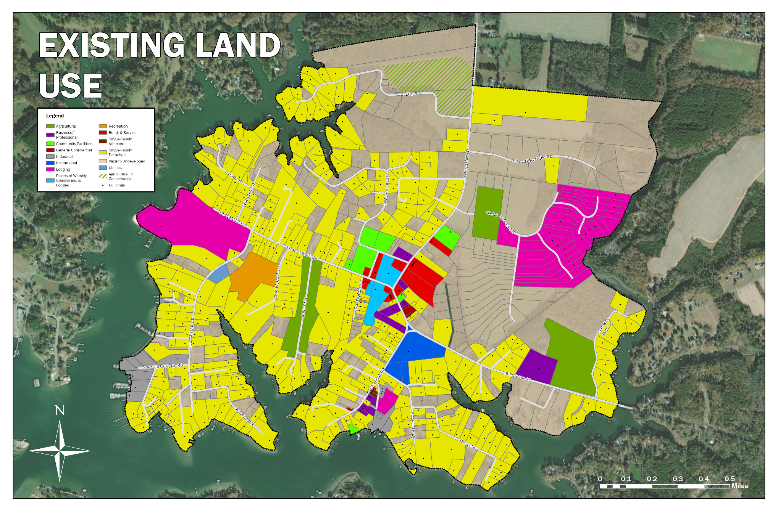
Source: EPR Analysis (2023)

Map 6: Existing Zoning Districts
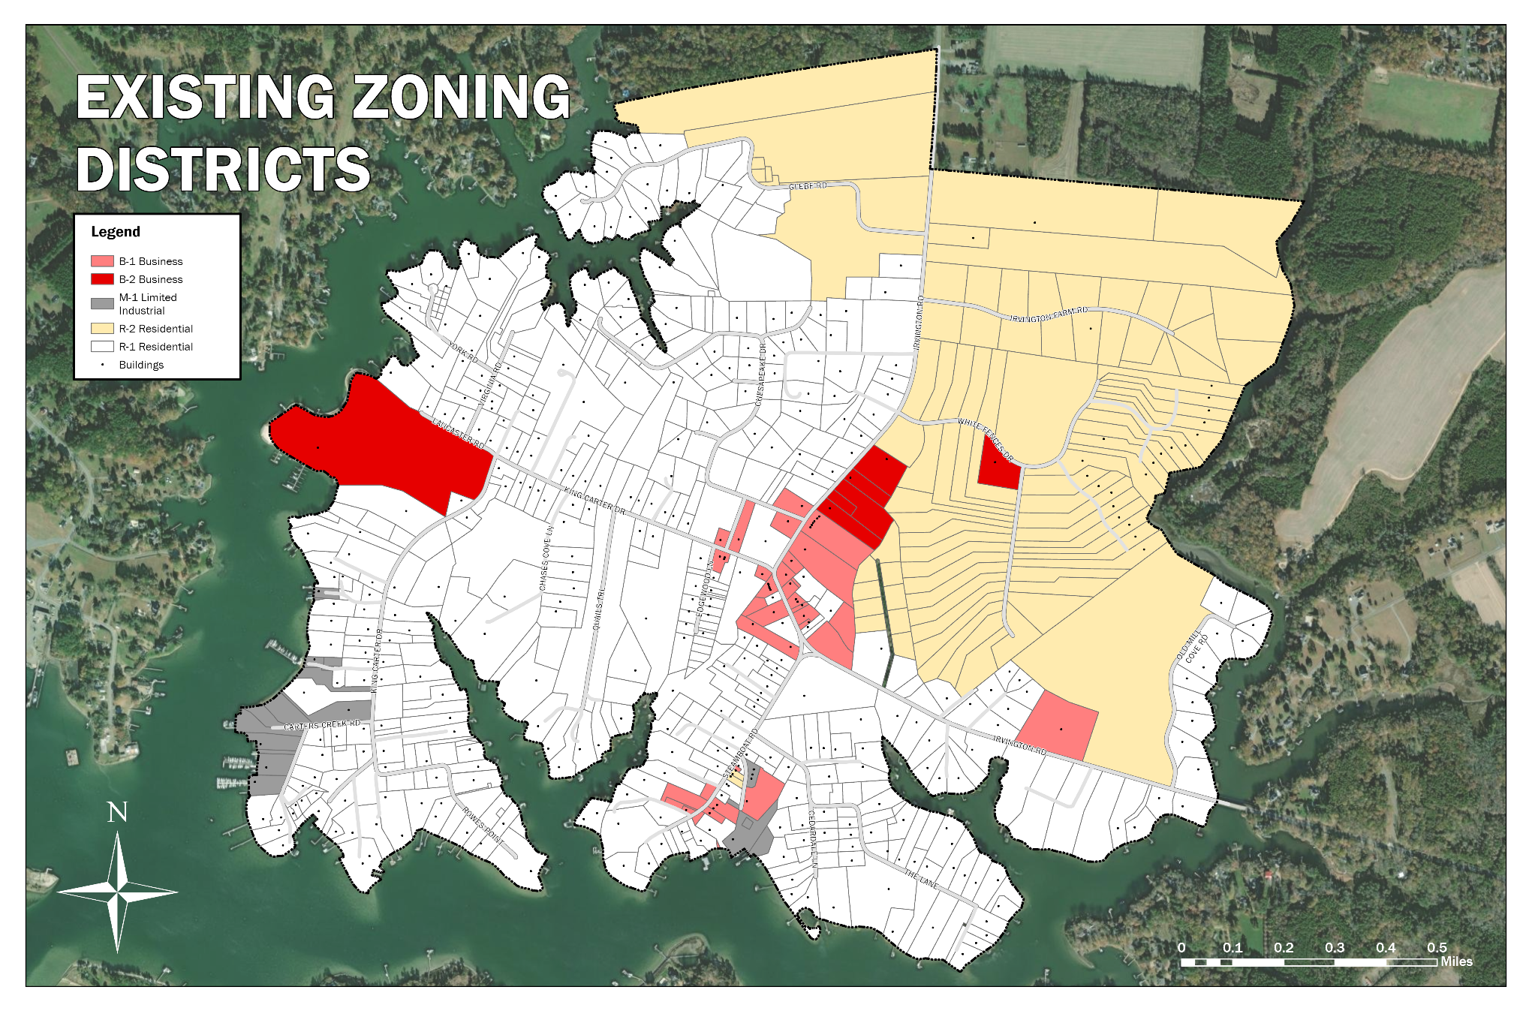
Source: EPR Analysis (2023)

Public Input

Community Survey
In conjunction with EPR, P.C., the Town conducted a 17-question community survey from June 1st, 2022, to July 15th, 2022. All town property owners, full-time residents, part-time residents, and business owners were invited to take the survey. Participants were given the option to take the survey online or send in a hardcopy version of the survey via mail. The Town received a total of 395 surveys (292 hard copies, 103 online). A summary of all survey responses can be found in Appendix A.

Responses were generally consistent with the content of the 2017 comprehensive plan. Key takeaways included:
- General support for new businesses and restaurants in town (especially locally-owned ones);
- General support for new families and full-time residents in town;
- If new housing were to be built, most respondents would prefer it to be consistent with what currently exists in town;
- General support for bicycle and pedestrian trail improvements (including connections with surrounding areas);
- Most participants felt that growth should occur thoughtfully and be consistent with the town’s existing character;
- Divided opinions on the following topics:
  - The prospect of a public sewer system;
  - Potential improvements to the town’s waterfront, including public waterfront access;
  - The intensity of future residential development;
  - The potential implementation of a meals tax;
  - Proposed improvements to the Town Commons; and
  - Proposals to extend sidewalks and implement more traffic calming measures.

Stakeholder Meetings
To better understand residents’ views on survey topics where there was little to no consensus, EPR, P.C. staff conducted a series of stakeholder meetings in early 2023 to discuss these issues in depth. The consultants spoke with nearly thirty stakeholders, including long-time residents, newer residents, business owners, property owners, and former council members. A summary of responses from the stakeholder meetings is below.
Public Sewer
- A need for more information about cost, feasibility, etc., before forming an opinion;
- Support for a limited option that serves King Carter Dr. and the Tides Inn;
- Support for a public sewer system that serves the entire town with optional connection;
- Concern that a public sewer system would enable unwanted growth; and
- Some opposition to a public sewer system in general.

Waterfront Access
- A sentiment that the Gaskins property is sufficient for public waterfront access. If it were to change hands, the Town should pursue a right of first refusal;
- General support for amenities like a fishing pier, a small waterfront park, a restaurant with waterfront access, a place to put small craft in the water, etc., but a sense that they should not be prioritized over more pressing needs;
- Some concerns that public water access in town would attract too many people and unwanted traffic; and
- A need for more information about cost, feasibility, purpose, etc., before forming a strong opinion either way.

Future Residential Development
- General support for the preservation of the town’s existing character;
- Acceptance of additional single-family residential development in line with existing zoning that happens without any specific intervention by the Town;
- Opposition to multifamily housing; and
- A need for more small, less expensive single-family housing options for young families and those looking to age in place.

Meals Taxes

- A need for more information and clarity on what the Town would use the meals tax for before forming a strong opinion either way;
- Conditional support for a meals tax with a defined purpose and end date;
- Opposition to any additional taxes and a sense that the Town has enough money; and
- Support for a meals tax of around 2.5% to support a public sewer system.

Town Commons Improvements

- General support for minor, inexpensive improvements to landscaping, beautification, etc.;
- Support for public restrooms,
- Support for resurfacing the tennis courts;
- Support for refurbishing the playgrounds;
- Satisfaction with things the way they are; and
- Opposition to spending significant money on improving the Commons.

Sidewalk Improvements

- General support for repairing existing sidewalks;
- Some support for extending the sidewalk to the other side of Irvington Rd.;
- Some support for filling in gaps where there is no sidewalk;
- General opposition to installing sidewalks in West Irvington due to ditches, encroachment on private property; and
- Some support for widening sidewalks where feasible.

Traffic Calming

- All participants were in favor of some form of traffic calming in town;
- Some participants were in favor of enhanced enforcement, speed traps, a police officer on duty, etc.;
- Some support for speed bumps and bump-outs;
- Some support for traffic circles and other efforts that could also enhance beautification; and
- Some support for enhanced golf cart access throughout the town and improvements to road crossings and parking.

Key Takeaways
The community survey and subsequent stakeholder meetings elicited valuable input regarding Irvington’s future. Respondents generally expressed support for new local businesses, restaurants, families, and full-time residents. Moreover, they desired any new housing to be consistent with the town’s existing style and called for thoughtful growth that maintains its character. However, residents were divided over several critical issues, such as introducing a public sewer system, waterfront improvements, the scale of future residential development, a potential meals tax, improvements to the Town Commons, and the extension of sidewalks and traffic calming measures. The results of the stakeholder meetings further elucidated these contentious topics, highlighting a recurrent need for more information and clarity on the details and financials of proposed changes and an overarching desire to preserve the town’s character while balancing growth and community needs. These findings underscore the necessity of careful planning, clear communication, and community engagement in any future developments and decisions in Irvington.

Development Interest
Note: this section is unchanged from the 2017 comprehensive plan. We will update this section to reflect the most recent development interest for the updated plan.

Several landowners and developers have expressed an interest in development on land they control. In all cases, land has already been subdivided and approved by the Town to develop additional single-family homes. The highlights of these “development interests” are outlined in the following section.

Approved Development
Vineyard Meadow – twenty-five (25) lots of approximately 2 acres each have been subdivided and approved for single-family homes along White Fences Road and the paved Road to Nowhere. At this point, no development has occurred.

Irvington Farms – Seventeen (17) lots of approximately 2 acres each have been subdivided and approved for single-family homes along paved Irvington Farms Road. At this point, no development has occurred.

Unnamed Subdivision – Ten (10) lots ranging from 0.7 to 1.2 acres each have been subdivided and approved for single-family homes along an unnamed right-of-way that runs north-south just to the east of the house at 4693 Irvington Road. At this point, no development has occurred.

Revival and Renovation of Tides Inn – The renovations/new construction are planned to expand and vary the accommodations and opportunities at the Tides Inn to attract a larger clientele. The owners aim to provide additional benefits to residents and transient guests. There are three major components to the proposed renovations:

- The Spa - The current spa will be transformed into an upscale, enhanced facility that will allow the Tides Inn to compete with the best spas in the country. Larger, more luxurious guest rooms and a wider array of treatment options will be available at the new Spa.
- Conference Facilities - A new 13,000-square-foot conference center will be constructed to expand business uses and create opportunities for locals to use the Tides Inn for their meetings.
- Condominium Hotel Rooms - The Tides Inn will grow to approximately 167 rooms once renovations and new construction are fully completed. These will consist of approximately 49 rooms in the “Old Inn”; the remaining are newly constructed condominium hotel and cottage units.

The plans for the revival and renovation of the Tides Inn have been approved in concept by the Town, but at this point, no development has occurred.

Downtown Development Proposal
An Irvington property owner and regional developer has put forward a vision for the central business district of Irvington as a mixed-use development with pedestrian and bicycle connections that blends residential, commercial, cultural, and institutional uses in which those functions are physically and functionally integrated. This mixed-use development would take the form of a “town block” of mixed-uses in a complex of buildings along both sides of Irvington Road with small office, business, retail, and restaurant establishments at the ground level, moderately priced apartment or condominium residences on the upper floors, and off- street parking to minimize impacts on Irvington Road. This development would utilize a consistent design concept and have a strong neighborhood character, continuing the trend that started with the recent development of the Trick Dog restaurant and adjoining shops. The actual plans and details are still under consideration.

The Town recognizes that there has already been much investment in acquiring land resources to implement this vision. The planned improvements for the central business district of Irvington, in conjunction with the long-term plans for improvements at the Tides Inn, should bring much-needed business activity to Irvington. The final concept of small offices, unique shops, boutiques, restaurants, and appropriate housing in Irvington would align with other planned town redevelopment activities.

Planned Unit & Clustered Development
Because none of the previously approved subdivisions has yielded any new development to date and because of the interest in developing downtown Irvington with a mixed-use concept, the Planning Commission endeavored to educate itself in approximately 2018 regarding the efficacy of potentially creating and including a Planned Unit/Cluster Development ordinance in the Town’s Zoning Ordinance. This new, more flexible type of zoning has been popular and useful in urban areas for many years and is also finding more acceptance in rural and small-town settings. The flexibility allowed under a Planned Unit Development accommodates a developer’s interest in more intensive development in exchange for requiring additional up-front planning that lays the groundwork for the type and character of development a locality wants to see occur. The following is provided as additional background information for this plan.

As defined in the Code of Virginia, a “Planned Unit Development (PUD) means a form of development characterized by unified site design for a variety of housing types and densities, clustering of buildings, common open space, and a mix of building types and land uses in which project planning and density calculation are performed for the entire development rather than on an individual lot basis.”

A PUD, as allowed by local ordinance, has several unique characteristics that encourage and enable a more flexible and livable development pattern that provides for greater density while preserving public or open space. These characteristics include:

- Floating Zone – a PUD is a “floating zone” that is not designated on the locality’s adopted zoning map but is one that a developer can request to provide for the unified development of several smaller adjoining parcels or a large parcel of land. Most communities require a minimum amount of contiguous land to qualify for a PUD ranging from 25 acres in a rural area to 10 acres in a more urban environment.

- Mixed-Use – very often, a PUD allows for a mix of uses, such as residential and retail, to be constructed on a single parcel (before sub-division) or for the assembled parcels to be developed. This mix of uses aims to make for a more walkable community, much like the communities of old where a corner store was always within walking distance of neighborhood homes. The allowable uses can be any allowed by the adopted Zoning Ordinance or can be restricted by various limiting provisions:
  - Restricted to the allowable uses for the underlying zoning district.
  - Restricted by a maximum percentage of specific uses. Example: where the original zoning might have been residential, retail or commercial use can be limited to 25% of the allowable square footage for the development.
  - Restricted by a limiting statement such as “structures and uses will adequately safeguard the health, safety, and welfare of the occupants of the adjoining and surrounding property.”

- Unified Site Design – rezoning under a PUD is approved only upon submitting a preliminary master plan, which, once approved, becomes the final master plan. Unified site design typically includes:
  - A site plan;
  - A land use plan;
  - Development regulations, including setbacks, height, building coverage, lot coverage, densities, parking requirements, and landscaping guidelines;
  - A roadway/circulation plan;
  - A public services/utilities plan;
  - An open space plan;
  - Preliminary architectural renderings and design guidelines of sufficient detail to clearly show and describe the intended development;
  - A delineation of the ownership structure after development, including the disposition of common lands; and
  - A development schedule if the development is large enough or the market is such that phasing will be required.

- Clustering - the typical PUD “clusters” development onto the more accessible portions of the original parcel to preserve undeveloped land as shared space for public use, such as active recreational or park land, or as partially- or fully-restricted conservation land. In an urban environment, the preserved land might have to be only 10% to 15% of the parcel; in a small-town or rural environment, approximately 25% of the parcel; and in a rural setting, for land conservation, as much as 50% of the land.

- Density Bonus – as an incentive for setting aside the common space, the developer is awarded a “density bonus” for the areas to be developed so that the development is genuinely clustered. Typically, the density cannot exceed what would have been allowed if the original parcel was developed. Example: Ten 3,000 square foot homes on 2 acres, each subdivided from a 20-acre parcel, would equate to 30,000 square feet of development that could be clustered perhaps onto 10 acres of the land, preserving the remaining 10 acres as common space.

- Preservation of Existing Character or Creation of an Urban Village - in addition to maintaining common space, one of the primary goals for PUD development is to place active development in a location on the site that is adjacent to and mirrors what is nearby (such as a small-village feel or the urban street grid) instead of having development at the back of parcels with large swaths of open land that can never be developed in the future or, in the case of an urban setting, large parking lots adjacent to the street grid. Many “New Urbanism” style developments have been developed using a PUD to create a close-knit village atmosphere or a more urban community.

Key Takeaways
This section to be completed.

Economy
Irvington developed as a steamboat community during the 1890s and early 1900s. The town’s position along the shores of Carter’s Creek supported both commercial enterprises and tourism, and the town quickly grew into a bustling village offering expanded business enterprises catering to the needs of out-of-town visitors.

An unfortunate fire in 1917 destroyed much of the town, and the end of the steamboat era left Irvington’s economy in a transitional period for several years. Despite these setbacks, present-day Irvington has retained its original charming village aesthetic, a point of pride for residents. Irvington continues to benefit from its idyllic location near the Chesapeake Bay; however, traditional water-based commercial enterprises based on aquaculture have been replaced by service-oriented activities based on tourism and recreational boating. Present-day Irvington is perhaps most well known as the location of the Tides Inn, which opened in 1947 and continues to bring a steady stream of visitors to the town.

Existing Business Mix
Irvington is home to a tourism-based economy and its associated support industries. Residents depend largely on establishments in nearby Kilmarnock and White Stone for everyday goods and services. Figure 9 details the existing business mix of the towns of Irvington, White Stone, and Kilmarnock. Most businesses within this three-community “triangle” are concentrated in Kilmarnock and are in the Retail Trade sector. Figure 10 provides a detailed look at this sector and the types of retail establishments within each locality. It is worth noting that Irvington has 10 establishments paying a meals tax, indicating the high percentage of businesses that rely on visitors from outside the the town and area.

Figure 9: Number of Establishments by Business Type, 2023

NAICS Code | Irvington | White Stone | Kilmarnock
Agriculture, Forestry, Fishing, and Hunting | 0 | 1 | 0
Mining | 0 | 0 | 0
Utilities | 0 | 0 | 0
Construction | 1 | 5 | 20
Manufacturing | 5 | 3 | 9
Wholesale Trade | 1 | 1 | 9
Retail Trade | 6 | 17 | 68
Transportation and Warehousing | 1 | 1 | 3
Information | 1 | 1 | 9
Finance and Insurance | 4 | 3 | 19
Real Estate and Rental and Leasing | 2 | 8 | 14
Professional, Scientific, & Tech Services | 8 | 9 | 26
Management of Companies & Enterprises | 0 | 0 | 15
Administrative, Support & Waste Management Services | 0 | 0 | 1
Educational Services | 1 | 0 | 46
Health Care & Social Assistance | 0 | 2 | 2
Arts, Entertainment & Recreation | 5 | 1 | 30
Accommodation & Food Services | 7 | 3 | 30
Other Services (except Public Administration) | 3 | 4 | 46
Public Administration | 1 | 4 | 4
Unclassified Establishments | 2 | 2 | 7
Total | 48 | 65 | 319
Source: ESRI

Figure 10: Retail Establishments by Business Type, 2023

NAICS Code | Irvington | White Stone | Kilmarnock
Motor Vehicle & Parts Dealers | 0 | 2 | 8
Furniture & Home Furnishings Stores | 0 | 2 | 1
Electronics & Appliance Stores | 0 | 0 | 3
Building Material & Garden Equipment & Supplies Dealers | 0 | 3 | 4
Food & Beverage Stores | 0 | 4 | 10
Health & Personal Care Stores | 0 | 0 | 7
Gasoline Stations & Fuel Dealers | 0 | 1 | 3
Clothing, Clothing Accessories, Shoe and Jewelry Stores | 2 | 0 | 15
Sporting Goods, Hobby, Book, & Music Stores | 4 | 4 | 12
General Merchandise Stores | 0 | 1 | 5
Source: ESRI

Irvington’s business mix is limited to small, local enterprises catering to out-of-town visitors. The town’s commercial center is characterized by retail trade, professional services, and locally-run luxury boutiques, with a notable absence of day-to-day retail and convenience goods. By contrast, Kilmarnock’s retail environment is more varied.

The following analysis details which retail sectors are represented or underrepresented in Irvington. It should be noted that the town is home to a large seasonal population. Therefore, the town is somewhat limited regarding the types of establishments it can realistically support.

Key Represented Retail Sectors

- Clothing & Clothing Accessories Stores: There are two clothing stores in town, each offering a limited selection of boutique items. Residents seeking everyday wear at affordable prices must travel outside the town to Kilmarnock or further.
- Boat Services: The Town is home to Rappahannock Yachts, a company with services that include new and used boat commissioning, routine yacht maintenance, and full custom restoration. The company’s history is rooted in servicing commercial boats for watermen working in the Chesapeake Bay and its tributaries, and it has made its home along Carter’s Creek for over 35 years. Additionally, Custom Yacht Service is a full-service boatyard specializing in the maintenance and repair of fine pleasure craft in Irvington. Custom Yacht Service offers in-house carpentry, fiberglass, paint, mechanical, and systems expertise to projects big and small.

Key Underrepresented Retail Sectors

- Food & Beverage Stores: The Citgo gas station in Irvington carries a limited assortment of grocery items/Irvington’s nearest full-service grocery stores are the Tri-Star Supermarket and Food Lion in Kilmarnock. Residents must travel outside the town to buy most of their food items.
- General Merchandise Stores: The Walmart Supercenter in Kilmarnock is the closest convenient location for residents to shop for general home goods and personal care items.
- Health & Personal Care Stores: The town does not have a local pharmacy. Residents must travel to Kilmarnock to fill prescriptions and purchase over-the-counter remedies.

Town Employment
Figure 11 provides a detailed breakdown of each industry within the town by the number of establishments and employees in 2023. Local employment opportunities are relatively limited and are primarily concentrated in service-providing industries. Employers in Irvington support an estimated 442 workers. However, the local labor force only accounts for a fraction of this total. According to U.S. Census Bureau data, as of 2020, 89% of Irvington’s local labor force worked outside the town. This trend indicates that many workers commuting into Irvington to staff local establishments do not live there.

Figure 11: Employment Breakdown for Irvington (2023 Estimates)

NAICS Code | Number of Establishments | Number of Employees
Accommodation & Food Services | 7 | 193
Finance and Insurance | 4 | 67
Professional, Scientific, & Tech Services | 8 | 41
Educational Services | 1 | 32
Arts, Entertainment & Recreation | 5 | 31
Manufacturing | 5 | 26
Information | 1 | 16
Retail Trade | 6 | 12
Real Estate and Rental and Leasing | 2 | 11
Construction | 1 | 4
Transportation and Warehousing | 1 | 3
Other Services (except Public Administration) | 3 | 3
Public Administration | 1 | 2
Wholesale Trade | 1 | 1
Agriculture, Forestry, Fishing, and Hunting | 0 | 0
Mining | 0 | 0
Utilities | 0 | 0
Management of Companies & Enterprises | 0 | 0
Administrative, Support & Waste Management Services | 0 | 0
Health Care & Social Assistance | 0 | 0
Unclassified Establishments | 2 | 0
Total | 48 | 442
Source: ESRI

The Tides Inn
The Tides Inn is by far the largest employer in Irvington, accounting for 35% (156) of all employees within the town and 81% of total employment in the Accommodation & Food Services sector. The Tides Inn also serves as a significant tourism asset for the town.

Northern Neck Insurance Company
The Northern Neck Insurance Company is the second-largest employer in Irvington and will employ an estimated 50 persons in 2023. Northern Neck Insurance Company’s client base extends far beyond Irvington and the Northern Neck region, and its employees represent 75% of the town’s total Finance & Insurance sector employment.

Chesapeake Academy
The Chesapeake Academy is an independent co-educational day school serving students in pre-kindergarten through eighth grade from the Northern Neck and Middle Peninsula regions. The Academy employs roughly 32 people and has been an institution in Irvington since its founding. The Chesapeake Academy makes up 100% of the town’s total Educational Services sector employment.

Income
Local income levels provide a snapshot of the local socioeconomic conditions. Figure 12 provides a detailed breakdown of the comparative income status for Irvington and the surrounding communities of the Northern Neck region. Irvington’s median household income is higher than its regional counterparts and the Commonwealth overall.

Figure 12: Comparative Income Status (2021 Estimates)

Locality | Median Household Income | Margin of Error
Irvington | $109,861 | ±$40,058
Kilmarnock | $37,589 | ±$7,146
White Stone | $45,417 | ±$23,158
Northern Neck | $59,455 | ±$12,307
Lancaster County | $64,460 | ±$8,707
Northumberland County | $61,291 | ±$7,873
Richmond County | $58,955 | ±$26,095
Westmoreland County | $53,113 | ±$6,554
Virginia | $80,963 | ±$731
Source: U.S. Census Bureau American Community Survey 5-Year Estimates

The American Community Survey also estimates that in 2021, up to 5.3% of Irvington residents were below the poverty level, even with the town’s higher overall income. Comparatively, 10.9% of Lancaster County’s population was reported below the poverty level during the same time frame.

Irvington is home to a high proportion of adults over the age of 62 who may be reliant upon Social Security as their primary source of income. Some of these older adults may be previously self-employed individuals who do not have significant additional resources to draw upon in retirement. Households that mainly rely on or only have Social Security income in retirement often are low-income. The 2021 American Community Survey estimates support this theory in that perhaps as many as 14.2% of persons 65 years old and older in Irvington have annual incomes below the poverty level.

Figure 13 provides a detailed breakdown of income sources by locality. At the town and regional levels, the proportion of households with Social Security income is significantly higher than those at the state level. This trend speaks to the comparatively high number of retirees living in the Northern Neck region and Irvington.

Figure 13: Comparative Income Sources (2021 Estimates)

Locality | Percentage of Households with Social Security Income | Percentage of Households with Retirement Income
Irvington | 48.4% | 28.2%
Northern Neck | 40.6% | 27.3%
Virginia | 29.5% | 26.7%
Source: U.S. Census Bureau American Community Survey 5-Year Estimates

Key Takeaways
Irvington has retained the village environment associated with its initial founding as a thriving steamboat community. This characteristic sets it apart both economically and aesthetically from surrounding localities. The town’s present economy comprises primarily small, locally-run enterprises, with the notable exceptions of the Tides Inn, Northern Neck Insurance Company, the Chesapeake Academy, Custom Yacht Service, and Rappahannock Yachts. Local businesses are supported mainly by out-of-town visitors and offer goods and services that cater to that demographic. Irvington’s major employers attract employees from surrounding localities.

The size of Irvington’s existing labor force is insufficient to support the staffing needs of the town’s major employers, as evidenced by the fact that most of their employees commute to Irvington from surrounding localities for work. Town residents must travel outside of the community to access basic goods and services, such as grocery items and affordable, everyday clothing.

The size of the existing permanent resident population and the town’s proximity to larger commercial centers limit its ability to realistically support a more robust retail base. However, exploring obstacles restricting access to essential goods and services may be worthwhile.

Community Facilities

Town Office
Irvington’s Town Office is located at 4203 Irvington Road. There is discussion among Town leadership about seeking a better situation for Town Hall before Oct of 2025

The Commons / North Commons
The Town’s Commons is a 3.16-acre parcel on King Carter Drive at Tavern Road. Mainly an open area for public events such as the Irvington Farmers Market, the Commons also includes tennis courts with an adjoining garden and a small gazebo. There is also a seldom-used softball diamond and backstop on the property.

The North Commons is two parcels totaling 3.24 acres just north of the Commons across Chesapeake Drive. The North Commons is undeveloped at this point.

There have been many discussions about how to develop the Commons/North Commons, but no definitive plans are in place at this time.

Waterfront
All of Irvington’s shoreline is under private ownership. While most of this land contains private residences, other parcels are either undeveloped or home to a waterfront business. Entities like the marinas, the Tides Inn, and the Rappahannock River Yacht Club provide partial public access to state waters, but only for members, customers, and guests.

One privately owned parcel located off Steamboat Road, called Gaskins Landing, provides public access to the Eastern Branch of Carter’s Creek. The site owners allow the public to take advantage of the boat ramp and limited parking for a voluntary fee or donation. Besides Gaskins Landing, Irvington has no areas designated for public access or public use along its shoreline.

Utilities
Irvington has a central water system consisting of a well, storage tank, and distribution lines owned, operated, and maintained by Aqua Virginia. The system serves over 300 residential and non-residential customers, including the Tides Inn. The primary well is located just off King Carter Drive near the entrance to the Tides Inn. Over the years, residents have complained about water quality, but per Aqua Virginia, the water meets all applicable water quality standards.

Irvington does not have a central sanitary sewer system. Homes and businesses are dependent on on-site septic systems for their sewage disposal. The Tides Inn operates its own packaged sewage treatment plant.

The most feasible means of providing a central sanitary sewer system for Irvington would be to tap into the system and treatment facilities operated by Kilmarnock. As a part of the 2017 Comprehensive Planning process, a Town representative met with Kilmarnock officials to explore this possibility. The outcome of that meeting was as follows:

- As of 2017, Kilmarnock’s sewage treatment plant was at 50% capacity and could accommodate Irvington.
- Despite the excess capacity, major upgrades would have to be made to the plant. The exact cost of the upgrades could not be determined without an extensive study.
- Irvington would be responsible for the cost of the upgrades.
- The exact cost of the lines cannot be determined without an extensive study. However, piping and pump stations cost approximately $45 per linear foot for a similar project several years ago from Wiggins Street to Harris Road. That amount would likely be higher today.
- The distance from Harris Road at its intersection with Irvington Road (the current extent of the sewer lines and pumping capacity at this point) to Irvington and all the road miles in Irvington total approximately 8.2 miles.
- The lines and necessary pump stations would cost approximately $1,948,000 ($45/linear foot * 5,280 feet/mile * 8.2 miles).
- The cost for lateral connections to the residences and businesses is $8,040. This is a fee the property owner would pay for hook-up to the system.
- “Out of Town Sewer Administration Fee” (water & sewage cost per household) would be $375.00 bi-monthly.
- Because sewage use is calculated based on the amount of water coming into a property, Kilmarnock would not allow sewer connections without connecting to its water system.

Given the above costs, it was determined in 2017 that a central sewer system for Irvington was not feasible. However, it was recommended that the Town Council should determine what grant funds might be available to defray these costs and revisit the possibility in the future. Such as study has now been commissioned.

Other Facilities
Public schools are the responsibility of Lancaster County, but Irvington is home to the Chesapeake Academy, a private school serving students from pre-kindergarten through 8th grade. Irvington is also home to the Irvington United Methodist Church, Irvington Baptist Church, and the Odd Fellows Lodge.

Key Takeaways
The public engagement process for this comprehensive plan update revealed conflicting opinions among residents on the level of investment the Town should pursue regarding improvements to community facilities and amenities such as the Town Office, the Commons, and public waterfront access, as well as the prospect of bringing a public sewer system to Irvington:

- The survey generally indicated little public support for significant investment in a new Town Office.
- There was general support for minor, inexpensive improvements to the landscaping and beautification of the Commons and refurbishment of the existing tennis courts and playgrounds.
- In terms of waterfront access, many residents indicated that the existing Gaskins property and other boat ramps and parks near Irvington provided sufficient public water access. However, many participants also expressed support for waterfront amenities such as a small park, a launching point for small watercraft, or a fishing dock, but there was a general sense that the Town should not prioritize these improvements over more pressing needs.
- The results of the community survey and stakeholder meetings confirmed that there is little consensus on how the Town should approach the potential installation of a public sewer system. Some participants supported either a townwide system or one that serves King Carter Dr. and the Tides Inn. In contrast, others voiced opposition to the concept altogether, feeling that their existing septic systems were sufficient and expressing concern about the cost of the installation and a sense that it could bring excessive residential and commercial development to Irvington. Still, many participants stated they would need more information about the cost, feasibility, and timeline of installing a public sewer system in town before forming an opinion.

Going forward, the Town should carefully consider feedback received during the public engagement process before committing to improvements to community facilities and amenities. Additionally, the Town should make every effort to provide as much information as possible regarding the costs, benefits, and potential drawbacks of any proposed improvements.

Transportation

Roadway Classifications
Irvington’s road network includes routes classified by the Virginia Department of Transportation (VDOT) as minor arterials and minor collectors. These classifications denote the kind of function each roadway serves. Arterials are intended to emphasize mobility, the efficiency by which traffic can move. Collectors are intended to emphasize access, connecting different uses along the route. Each functional classification exists on a scale between providing efficient mobility and access via points of entry and exit. The VDOT Functional Classifications are represented graphically in the Roadway Functional Classifications map.

Roadways and Traffic Volumes
The Town’s three primary roadways are Irvington Road (State Route 200), King Carter Drive, and Steamboat Road. Traffic volumes and Functional Classifications made by VDOT for each of these roads are explored in detail in the following section.

Figure 14 depicts traffic volumes for Irvington’s three primary roadways from 2011 to 2021. Traffic levels along King Carter Drive and Steamboat Road have remained relatively flat. However, traffic volumes along Irvington Road have increased in recent years.

Figure 14: Major Roadway Annual Average Daily Traffic (AADT), 2011-2021

 | 2011 | 2013 | 2015 | 2017 | 2019 | 2021
Irvington Road | 6300 | 6300 | 5500 | 5000 | 6000 | 7000
King Carter Drive | 587.5 | 587.5 | 540 | 572.5 | 575 | 667.5
Steamboat Road | 643.3 | 643.3 | 643.3 | 643.3 | 643.3 | 496.7
Source; VDOT

Irvington Road (State Route 200)
Irvington Road enters the town from White Stone to the east and serves as the town’s primary access road, connecting visitors and residents to the local commercial center and Kilmarnock to the north. VDOT classifies it as a Minor Arterial roadway. This classification generally indicates higher mobility through movement and linkages to cities, large towns, and other major traffic generators.

King Carter Drive
VDOT classifies King Carter Drive as a Minor Collector. This classification indicates that it collects traffic from major traffic generators and connects the local road network to larger arterial roadway systems.

King Carter Drive’s most heavily trafficked segment begins at its intersection with Irvington Road. It terminates at Winstead Drive, just before the gate of the Tides Inn, where it makes a sharp turn south following the ridge of the western peninsula. The Steamboat Era Museum, Hope & Glory Inn, and a concentration of single-family homes are located along King Carter Drive.

Steamboat Road
Steamboat Road intersects with Irvington Road at its northernmost point (known locally as “The Triangle”) and continues south to its natural terminus at the shore of Bridge Cove. It provides access to Chesapeake Academy, several local businesses, and an enclave of single-family homes with commanding views of the Eastern Branch of Carter’s Creek. Steamboat Road is not classified under the VDOT classification system even though it experiences comparatively high traffic volumes.

Due to high traffic volumes along these three major roads, traffic calming measures, including rumble strips, flashing warning lights, high visibility crosswalks with pedestrian flashing lights, and bump-outs, have been installed along Irvington Road at and near its intersections with King Carter Drive and Steamboat Road. These improvements have been somewhat effective in enhancing pedestrian safety and lowering the speed at which vehicles travel through the area.

Alternative Transportation Options
. Communities that foster walkable environments with a cohesive alternative transportation network see a decrease in car dependence and healthier, happier residents. Walkable communities further benefit from decreased parking demands and higher volumes of foot traffic along commercial corridors.

According to the Department of Housing and Urban Development’s Location Affordability Index for Irvington, a four-person household with two commuters earning the local median income drives an estimated 31,000 miles per year and spends approximately 29% of its annual income on transportation. Town residents must frequently travel to surrounding localities to access goods and services and are primarily dependent upon cars as their primary source of transportation. The burden of transportation increases to 36% of annual income for working individuals that must travel outside of Irvington to access employment opportunities.

Figure 19 details local means of transportation to work as provided by American Community Survey estimates. Note that public transportation as a means for commuting to work is excluded from these results as it is not currently available to Irvington residents.

Figure 19: Means of Transportation to Work (2011-2021 Estimates)

 | 2011 | Margin of Error (2011) | 2021 | Margin of Error (2021)
Drove alone | 212 | ±86 | 169 | ±62
Carpooled | 2 | ±4 | 16 | ±15
Walked | 0 | ±95 | 2 | ±4
Other means | 0 | ±95 | 5 | ±8
Worked at home | 53 | ±34 | 29 | ±20
Source: U.S. Census Bureau American Community Survey 5-Year Estimates

As Figure 19 indicates, private vehicles are the most common means of transportation to work for Irvington residents. However, it should be noted that the small sample size of the American Community Survey means that the margin of error is especially large for underutilized transportation. Despite this lack of precision, the findings demonstrate that very few workers in Irvington use modes of transportation other than personal automobiles when commuting to work.

Workers in Irvington generally do not walk to work, likely because little of the local workforce is employed within Irvington, making further commutes necessary. There has been a small increase in the number of reported bicycle commuters in the town.

Public and On-Demand Transportation
Irvington does not currently offer a public transportation network; however, several regional on-demand transportation options are provided through various sources, including Bay Transit and Virginia Rides. From late spring to early fall, the Triangle Trolley provides scheduled weekend and holiday services among Irvington, Kilmarnock, and White Stone, including other stops such as Historic Christ Church. Additional on-demand services are limited to seniors, persons with disabilities, and non-emergency medical needs.

Walking and Biking
Sidewalk connectivity within and around the central commercial corridor and surrounding neighborhoods generally meets residents’ needs. However, many who participated in the public engagement process for this comprehensive plan update indicated that some segments of existing sidewalks need repair, and there was widespread support among participants for repairs to the existing sidewalk network. Additionally, some participants expressed support for filling gaps where no sidewalks exist. However, there was some opposition to installing sidewalks in West Irvington due to potential encroachment on private property.

No formal bicycle infrastructure is currently in place, such as shared lane markings and/or protected bicycle lanes. This lack of infrastructure is a safety concern that should be mitigated, particularly along higher-traffic routes such as Irvington Road and King Carter Drive and perhaps Steamboat Road.

In recent years, Lancaster County has proposed a nine-and-a-half-mile walking and biking trail known as the “TriWay Trail,” which will connect Irvington, Kilmarnock, and White Stone. The planned trail, widely supported by citizens and representatives at all levels, will traverse the county’s growth zone and connect major service providers, entertainment complexes, and commercial establishments. Facilitated by a group of community volunteers under a public/private partnership, the initiative has received approval and financial backing from the county’s Board of Supervisors. The plan has garnered significant public support, with many property owners committed to donating rights-of-way.

The TriWay Trail plan proposes an asphalt multi-use path down White Fences Drive, eventually turning north out of town towards Kilmarnock. This multi-use path would connect with Irvington Road where it intersects with White Fences Drive. Additionally, the plan proposes widening sidewalks from 4’ to 6’ on Irvington Road from its intersection with White Fences Drive to its junction with King Carter Drive, an on-street bike lane down that segment of Irvington Road, and a spur trail/on-street bike lane down King Carter Drive towards the Tides Inn.

Key Takeaways
The Town’s current transportation infrastructure fosters a primarily car-dependent environment. Although sidewalk connectivity within the central commercial corridor and its surrounding neighborhoods is generally adequate, there are gaps in sidewalk coverage, and some segments of the existing sidewalk need repair. Additionally, some parts of town are largely isolated from alternative transportation networks. It is equally important to consider that connectivity to surrounding localities is currently limited to vehicular transportation. Because residents frequently travel along Irvington Road to access goods and services offered in Kilmarnock, it would be beneficial to explore options for increasing connectivity via the TriWay Trail and/or a scheduled shuttle service, should demand prove sufficient. The benefits of investing in alternative forms of transportation within the Town include increasing accessibility for existing and future residents and visitors, which in turn bolsters the “village” atmosphere that the Town has carefully cultivated throughout its history.

It is also essential to consider that many retired individuals are attracted to locations allowing them to “age in place, “meaning key recreational, cultural, community, and commercial amenities are available and conveniently accessible. Often, aging residents desire to eventually forego their car as their primary source of transportation to avoid the stress and financial burden of car dependency. Irvington’s current and projected demographic makeup emphasizes the importance of ensuring that the community meets the needs of retirees. Notably, the same accessibility is often desired by young families. Therefore, investing in an expanded transportation network is essential in ensuring that the Town provides for current and potential future residents.

Map 7: Roadway Functional Classifications
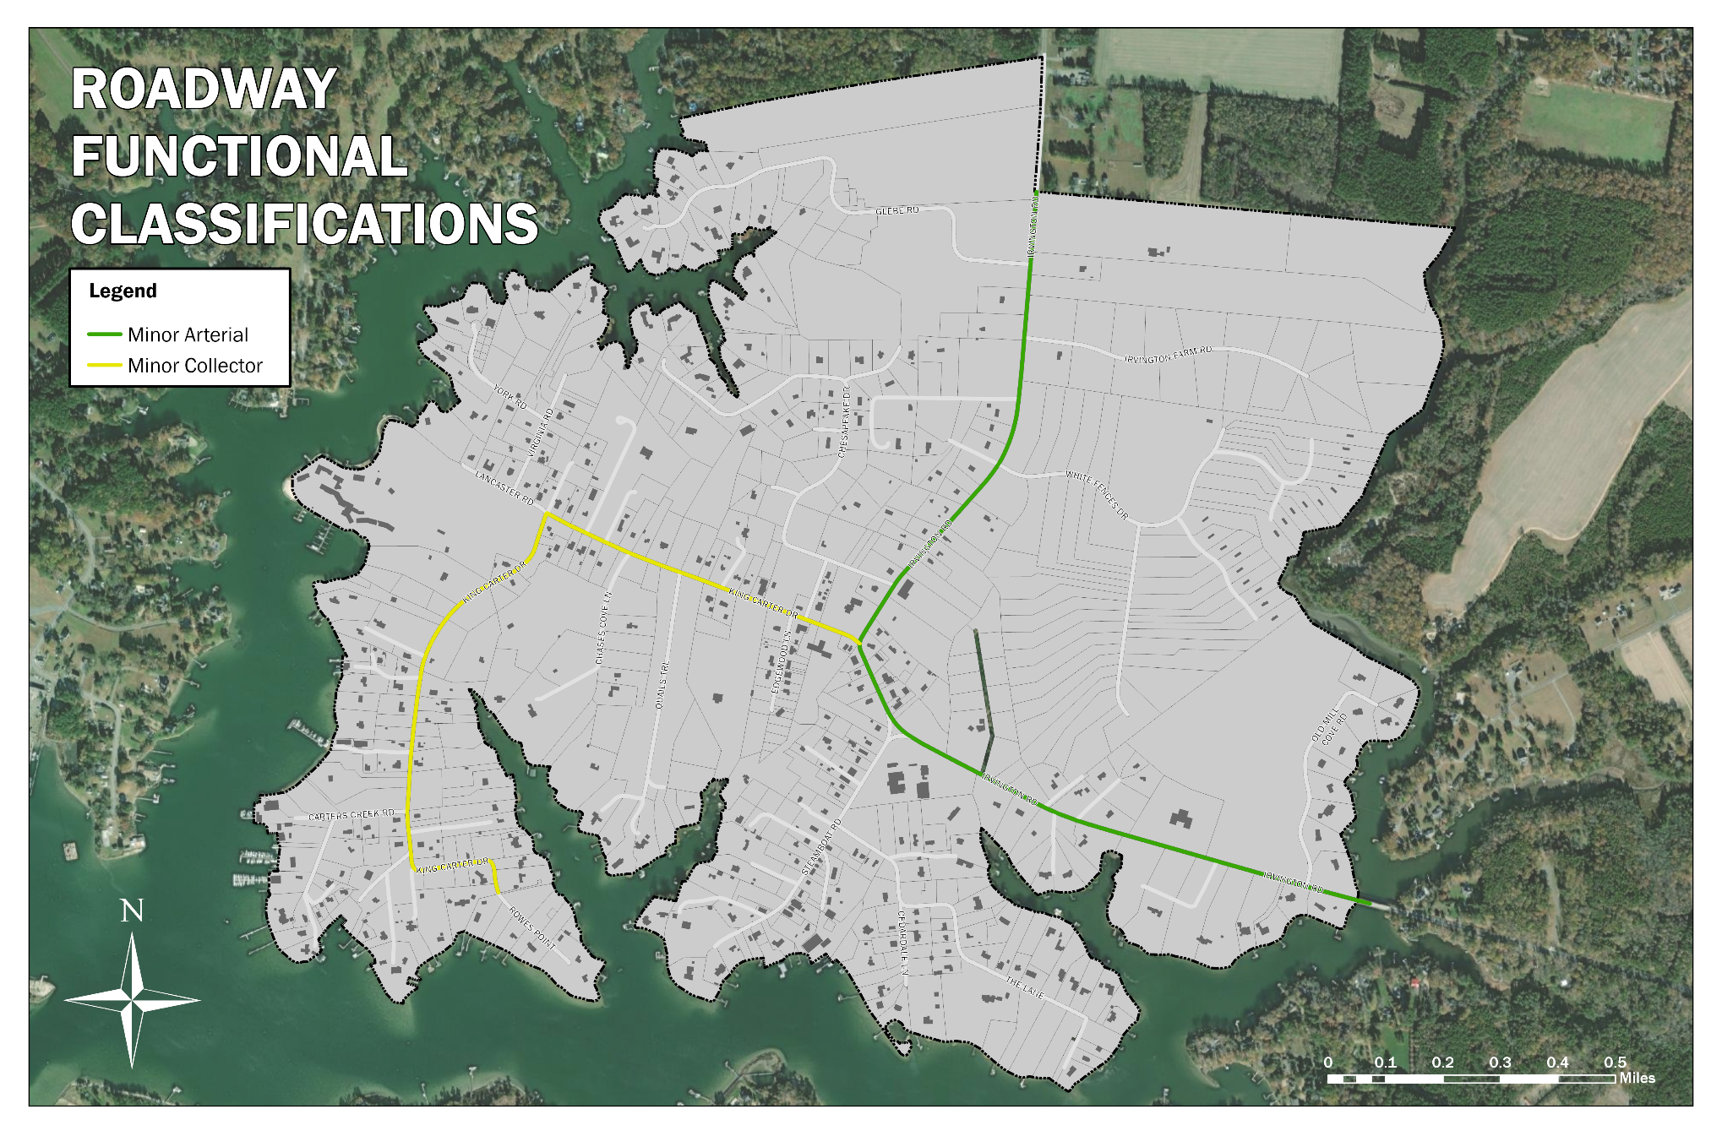
Source: VDOT

The Plan
The Plan component of a Comprehensive Plan is the section that outlines a community’s vision for its future and the goals, objectives, and strategies needed to move that vision forward. Per the Code of Virginia, the Plan component must also contain a generalized land use plan that encourages an orderly, harmonious arrangement of land that will meet the present and future needs of the locality. This is typically accomplished through a Future Land Use Map that represents the locality’s vision for the development and/or redevelopment of the land within its boundaries.

Goals, Objectives, Strategies, and Tactics

- Goal A: Preserve and enrich the Town of Irvington’s charm and attractiveness.
  - Strategy A-1: Protect existing real estate assets and historic resources.
    - Tactic (ordinance): Conduct an audit of the zoning and subdivision ordinances to determine code rewrites that would protect existing real estate assets and historic charm while balancing individual property rights.
    - Tactic (program): Explore beautification efforts to finance landscaping and maintenance of the Town’s streetscape and reduce traffic speed through town.
  - Strategy A-2: Assure that organic growth is consistent with the Town’s character.
    - Tactic (ordinance): Conduct an audit of the zoning and subdivision ordinances to determine code rewrites that would require appropriate densities and uses.
- Goal B: Enhance Irvington’s livability and promote community through a livable, walkable town.
  - Strategy B-1: Foster active living through bicycle and pedestrian improvements.
    - Tactic (policy): Cooperate with Lancaster County and the surrounding towns to implement the Three-Town Trail between Irvington, Kilmarnock, and White Stone.
    - Tactic (capital): Seek VDOT Transportation Alternative Program funding in several phases for the construction of planned public pedestrian and bicycle facilities.
    - Tactic (capital): Construct planned pedestrian and bicycle facilities as funds are awarded by VDOT and as matching funds become available.
    - Fund a multi year traffic calming plan that would clearly delinate “gateways” into Irvington on both end of Rt 200 and provide a plan for future funding that will reduce traffic speeds, deter heavy truck traffic and make Irvington more friendly to walking and biking.

- Goal C: Support Irvington’s tourism industry while preserving its quiet waterfront character.
  - Strategy C-1: Boost tourism by having a venue for regular outdoor concerts and other special events.
    - Tactic (capital): Invest in improvements to the Town Commons.
    - Tactic (program): Organize and host a community events calendar.
  - Strategy C-2: Foster local business development for a healthy and active main street.
    - Tactic (ordinance): Conduct an audit of the zoning ordinances to determine code rewrites that would support local business development while limiting chain stores.
    - Tactic (capital): Conduct a feasibility analysis for a public sewer system that would support existing and new local businesses.
    - Fund the traffic calming plan to build upon our unique and walkable community.
- Goal D: Foster Town unity and fellowship.
  - Strategy D-1: Provide a space for planned and informal recreational activities geared toward younger adults and young families.
    - Tactic (capital): Maintain playground equipment and other amenities for children.
    - Tactic (ordinance): Conduct an audit of the zoning ordinances to determine code rewrites that would support local restaurants.
    - Tactic (program): Organize family events and festivals that would draw families and children.
    - Fund the traffic calming plan so that adolescents and young adults can have the independence of going to businesses and coffee shops without relying on their parents’ driving them.

  - Strategy D-2: Encourage citizen participation in the governance of the Town of Irvington by having a more spacious and appropriate facility for community meetings.
    - Tactic (capital): Identify opportunities for a new town hall with meeting space.
- Goal E: Preserve and enhance Irvington’s waterfront charm.
  - Strategy E-1: Maintain existing waterfront access points.
    - Tactic (initiative): Create a relationship with the Gaskins family and a long term goal to preserve Gaskins Landing.
    - Tactic (capital): Formalize a right of first refusal for the Gaskins property in case the family wishes to sell.
    - Tactic (policy): If the Town secures the Gaskins property, commission a plan of development site improvements.
    - Tactic: Provide public support for the gravel and maintance of the landing as a gesture fo goodwill and appreciation of this private resource being, essentially, a public access point.
  - Strategy E-2: Provide tourism information on waterfront access points.
    - Tactic (program): Develop information materials on where visitors can get in their car and go drive somewhere else that isn’t Irvington to find waterfront access.
  - Strategy E-3: Maintain a working waterfront.
    - Tactic (ordinance): Conduct an audit of the zoning ordinances to determine code rewrites that would preserve waterfront operations on industrial land.
Strategy – Deny CUPs for future residential use on industrially zoned land and amend the Ordinance to reflect this intent.
- Goal F: Attract families and full-time residents that can help to preserve the Town’s sense of community.
  - Strategy F-1: Provide additional job opportunities within the Town by making it easier to live and work in Irvington.
    - Tactic (program): Monitor and engage in efforts by Lancaster County, the Northern Neck Planning District Commission, the Northern Neck Broadband Authority, and the Center for Innovation and Development to develop more robust internet connectivity in the area.
    - Tactic (program): Continually keep an eye on the public and nonprofit resources that might become available to boost the internet connectivity in the Town.
    - Use tax revenue for items that benefit town property owners only… for instance, a waterfront town park could be for the use only by taxpayers.

Future Land Use
This section will be updated after we receive comments/approval from the Town on the updated Goals, Objectives, Strategies, & Tactics.

Map 8: Future Land Use

This map will be completed after we receive comments/approval from the Town on the updated Goals, Objectives, Strategies, & Tactics.

Implementation

This section will be completed after we receive comments/approval from the Town on the updated Goals, Objectives, Strategies, & Tactics.

Appendix A: 2022 Survey Results

Figure 20: Respondents

Note: This figure shows percentages of total responses. Respondents could select multiple options.

Figure 21: Top Reasons for Choosing Irvington

Note: This figure shows percentages of total responses. Respondents could select multiple options.
Figure 22: Opinions on New Growth

Note: This figure shows percentages of total responses. Respondents could select multiple options.
Figure 23: Opinions on Town Businesses

Note: This figure shows percentages of total responses. Respondents could select multiple options.

Figure 24: Opinions on Attracting Young Families and Full-time Residents to Irvington

Figure 25: Opinions on Housing Types

Note: This figure shows percentages of total responses. Respondents could select multiple options.
Figure 26: Opinions on the Waterfront and Public Water Access

Note: This figure shows percentages of total responses. Respondents could select multiple options.
Figure 27: Desired Recreational Facilities

Note: This figure shows percentages of total responses. Respondents could select multiple options.

Figure 28: Opinions on Sewer Services

Note: This figure shows percentages of total responses. Respondents could select multiple options.

Figure 29: Support for Additional Taxes and Capital Spending

Figure 30: Opinions on a Town Meals Tax

Note: This figure shows percentages of total responses. Respondents could select multiple options.
Figure 31: Opinions on Short-Term Rentals

Note: This figure shows percentages of total responses. Respondents could select multiple options.

