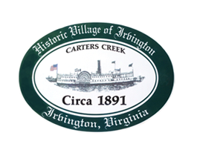

Public Meeting on Possible Charter Revision
May 9, 2024 at Irvington Baptist Church from 5:30 to 6:30 p.m.

AGENDA –
- CALL TO ORDER

- ROLL CALL
- FACILITATED CONVERSATION ON CHARTER LANGUAGE
  - Presentation of questions for consideration, J. Harris & C. Bradley
  - Public Input

- ADJOURN

