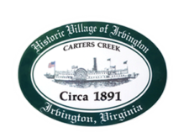
Town of Irvington Zoning Administrator Report
Prepared for Planning Commission & Town Council
Prepared For: November 2023 Regularly Scheduled Meetings
Staff Contact: Justin Nelson, Zoning Administrator

Zoning Permits:

2023-26, rebuild dock at 341 The Lane; convened the Board of Zoning Appeals about an addition at 25 Hundley Lane; BZA reversed the zoning administrators denial

Miscellaneous:
Additional receipts received from Mr Fisher for removal of debris; daily site visits to Tides Inn as construction has begun

visits to the Aqua well on King Carter for no/weak water flow; branch knocked out power the weekend of October 28-29 and caused multiple pump failures; that has been fixed; previous outages were from a backflow issue

