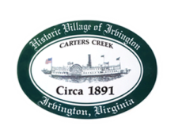
Town of Irvington Zoning Administrator Report
Prepared for Planning Commission & Town Council
Prepared For: October 2023 Regularly Scheduled Meetings
Staff Contact: Justin Nelson, Zoning Administrator

Zoning Permits:

2023-25, new deck 171 Park Place; 2023-26, rebuild dock at 114 Fleet Lane; received an application for an addition at 25 Hundley Lane which was denied because of setback ordinances; that has been appealed and will be heard by the Board of Zoning Appeals.

Miscellaneous:
Additional receipts received from Mr Fisher for removal of debris; site visit to Tides Inn as construction will begin the week of October 9th.

Follow up visits to the Aqua well on King Carter; well testing will be done week of October 2nd, scheduled completion is no later than October 6th.

If the two STR CUP applications before you are approved, we are at our limit with two additional applications on hold.

AES engineering has completed survey work for sidewalks to run from Accents (florist shop) to Vineyard Grove

