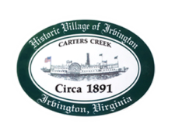
Town of Irvington Zoning Administrator Report
Prepared for Planning Commission & Town Council
Prepared For: January 2024 Regularly Scheduled Meetings
Staff Contact: Justin Nelson, Zoning Administrator

Miscellaneous:
Additional receipts received from Mr Fisher for removal of debris; daily site visits to Tides Inn as construction has begun; there are two STR slots now available and applications will be forthcoming for consideration.

