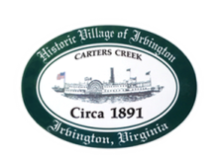
Town of Irvington Zoning Administrator Report
Prepared for Town Council
Prepared For: August 2023 Regularly Scheduled Meetings
Staff Contact: Justin Nelson, Zoning Administrator

Zoning Permits:

2023-23, new home for McNeely per recently approved CUP application, 69 Chinnis Lane

Miscellaneous:
Additional receipts received from Mr Fisher for removal of debris; multiple site visits to the Aqua new well being drilled on Carter’s Creek Rd, there was a spill of drilling sludge that impacted neighbors. Lancaster County has visited an mandated some clean up via hand tools by the well driller; met with neighbors, Tides Inn and DEQ on 8/2 on site; DEQ investigated and should have a response soon (this report prepared prior to any response from DEQ)
Two more STR CUP applications that, if approved in Septembers meeting, will fill the 35 slots allowed; an additional CUP for redevelopment in the RPA is forthcoming.

Tides Inn construction per their approved CUP should begin mid-October

