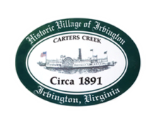
Town of Irvington Zoning Administrator Report
Prepared for Planning Commission & Town Council
Prepared For: March 2024 Regularly Scheduled Meetings
Staff Contact: Justin Nelson, Zoning Administrator

Permits:
Removal of dead tree in RPA, 79 Cedardale Lane; new pool, 173 Virginia Road

Miscellaneous:
Received additional sidewalk quote; CUP for the operation of an art gallery at 81 King Carter Drive; inspected the removed bamboo from Hall/Elliott property, looks great and Hall/Elliott are very pleased;
BZA will convene in late March to hear an appeal of a denied zoning permit for an addition at 52 Rowe’s Point Road, violation of setback.

Conditional Use Permit applications process is: 1) a joint public hearing with PC and TC wherein the application is read; 2) a vote on the application at the following regularly scheduled PC and then TC meetings.

