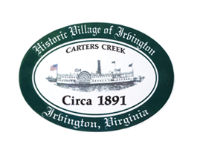

THE TOWN OF IRVINGTON
Sewer Committee Workshop
Town Office
Friday, February 16; 10AM

Agenda

- Attendees
- PER Debrief
- PER Presentation MTG Feb 27?
- Presentation Mtg Agenda
- USDA PER Submittal
- Adjourn

