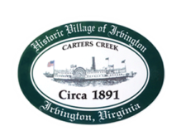
Town of Irvington Zoning Administrator Report
Prepared for Planning Commission & Town Council
Prepared For: April 2023 Regularly Scheduled Meetings
Staff Contact: Justin Nelson, Zoning Administrator

Zoning Permits:

#2023-10, new dock York Road; 2023-11 rebuild dock, Glebe Road; 2023-12, rebuild dock Irvington Road

Miscellaneous:
Additional receipts received from Mr Fisher for removal of debris; meet with three concrete contractors on locations of deteriorated sidewalks; walk-ins for property boundary dispute; property boundary re-draw, and zoning code for parking.

UPDATE: TC had authorized the hiring of two interns, and thanks to their and Town Clerk’s diligent hard work, every single file in the Town cabinets dating to Irvington’s founding has been gone through, BY HAND, and inspected and re-filed by tax map number rather than last name.

