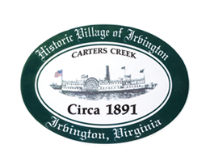

THE TOWN OF IRVINGTON

PLANNING COMMISSION REGULAR CALLED MEETING
Irvington Town Office, 4203 Irvington Rd., IRVINGTON, VA
Wednesday, November 8, 2023; 6:30PM

Preliminary Agenda

- Call to Order – T. Chapman

- Roll Call and Determination of Quorum – T. Chapman

- Welcome and Introductions for Robin Camillo

- Approve Minutes
- 9/5/2023 Minutes approval – T. Chapman

- Report From Chair- T. Chapman

- Public Comment

- Report from Zoning Administrator – J.Nelson

- Old Business
  - Zoning Permit – Stettinius – J.Nelson
  - Zoning Permit – Fooks – J. Nelson
  - Zoning Ordinance – Accessory Structures etc. – J. Nelson
  - Draft Comprehensive Plan Review status - T. Chapman
  - Status of enforcement recommendations – R. Fuller

- New Business
  - Action on revised STR Ordinance – T. Chapman

- Round Table - All

- Next meeting Election Day?
December 5, 2023, PC Regularly Scheduled Meeting at Irvington Town Hall, 6:30 p.m.

- Adjourn

