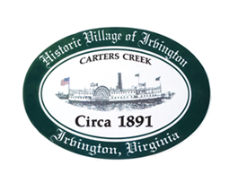

THE TOWN OF IRVINGTON
JOINT TOWN COUNCIL & PLANNING COMMMISSION
Comprehensive Plan Workshop

IRVINGTON BAPTIST CHURCH, IRVINGTON, VA
Tuesday, February 20; 5:30PM

Agenda

- Call to order

- Roll Call of Planning Commission

- Roll Call of Town Council

- Discussion of Proposed Changes to Draft Comprehensive Plan

  - R-2 Zoning / R-3
  - Traffic Calming – pedestrian safety in West Irvington
  - Introduction to Transportation section
  - Chesapeake recreation area legislation
  - Lancaster County 2035 issues
  - VDOT Review

- Adjournment

