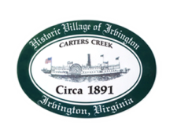
Town of Irvington Zoning Administrator Report
Prepared for Planning Commission & Town Council
Prepared For: December 2023 Regularly Scheduled Meetings
Staff Contact: Justin Nelson, Zoning Administrator

Zoning Permits:

2023-27, new dock on undeveloped parcel on Old Mill Cove; 2023-28 new house on undeveloped parcel on Pine Circle.

Miscellaneous:
Additional receipts received from Mr Fisher for removal of debris; daily site visits to Tides Inn as construction has begun; meeting with sidewalk parties to finalize sidewalk construction from Accents to White Fences

Year End Recap
Total permits issued were 28; 5 new homes permits; 3 redevelopment in RPA Conditional Use Permits; 1 new construction encroachment in RPA; 6 new/rebuild of docks; one meeting of Board of Zoning Appeals

