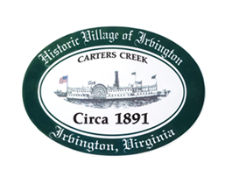

THE TOWN OF IRVINGTON

PLANNING COMMISSION REGULAR CALLED MEETING
Irvington Town Office, 4203 Irvington Rd., IRVINGTON, VA
TUESDAY, May 2, 2023; 6:30PM

Preliminary Agenda

- Call to Order – T. Chapman

- Roll Call and Determination of Quorum – T. Chapman

- Approval for Commissioner Pollard to participate electronically

- Approve Minutes
- 4/4/2023 Minutes approval – T. Chapman

- Election of Officers – T. Chapman

- Report From Chair- T. Chapman

- Public Comment

- Report from Zoning Administrator – Justin Nelson

- Old Business
a. CUP Clearview to operate a STR BUSINESS at 277 Steamboat Rd - J. Nelson
b. CUP_HB to operate a STR BUSINESS at 205 Steamboat Rd – J. Nelson
d. Capital Improvement Plan – T. Chapman
e. Enforcement recommendations plan – R. Fuller
f. Irvington House Counts – A. Pollard Jr

- New Business
a. Comprehensive Plan – EPRpc recommendations on Goals and Strategies – T. Chapman

- Next meeting
May 2, PC Regularly Scheduled Meeting at Irvington Town Hall, 6:30 p.m.

- Adjourn

