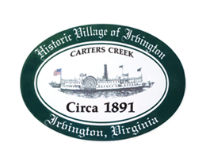

THE TOWN OF IRVINGTON

PLANNING COMMISSION REGULAR CALLED MEETING
Irvington Town Office, 4203 Irvington Rd., IRVINGTON, VA
TUESDAY, January 3, 2023; 6:30PM

Preliminary Agenda

- Call to Order – T. Chapman

- Roll Call and Determination of Quorum – T.Chapman

- Approve Minutes
- 12/6/2022 Minutes approval – T. Chapman

- Report From Chair- T. Chapman
- Secretary

- Public Comment

- Report from Zoning Administrator – Justin Nelson

- Old Business
  - STR Ordinance Amendment – T. Chapman
  - Comprehensive Plan Update Process – T. Chapman

- New Business

  - Fence Ordinance Amendment Progress – A. Pollard/L. Capps

  - Sign Ordinance Amendment Progress – D. Clarke/J. Taylor
- Review of Land Use (as time allows) – A. Pollard et. al.

- Next meeting
January 12, Joint PC TC Public Hearing and Joint Workshop on Commons Plan
Feb 7, 2023, at the Irvington Town Hall or Irvington Baptist Church, 6:30 p.m.

- Adjourn

