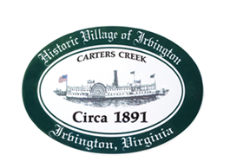

THE TOWN OF IRVINGTON

PLANNING COMMISSION REGULAR CALLED MEETING
Irvington Town Office, 4203 Irvington Rd., IRVINGTON, VA
TUESDAY, March 7, 2023; 6:30PM

Preliminary Agenda

- Call to Order – T. Chapman

- Roll Call and Determination of Quorum – T. Chapman

- Approve Minutes
- 2/7/2023 Minutes approval – T. Chapman

- Report From Chair- T. Chapman

- Public Comment

- Report from Zoning Administrator – Justin Nelson

- Old Business
  - Geier STR CUP action- j. Nelson
  - Amendment Recommendations for CUP requirement- J. Nelson
  - Comprehensive Plan Update Process – T. Chapman
  - Capital Improvement Plan – T. Chapman
  - Sign Ordinance Amendment Status - D. Clarke/J. Taylor

- New Business
  - General Discussion of Enforcement – A. Pollard

- Next meeting
March 9, 2023, Joint TC/PC Public Hearing at Irvington Baptist Church
April 4, PC Regularly Scheduled Meeting at Irvington Town Hall, 6:30 p.m.

- Adjourn

